Chapter 5
Elasticity and Its Applications
MULTIPLE CHOICE
1. In general, elasticity is
a. the friction that develops between buyers and sellers in a market.
b. a measure of how much government intervention is prevalent in a market.
c. a measure of how competitive a market is.
d. a measure of how much buyers and sellers respond to changes in market conditions.
ANSWER: d. a measure of how much buyers and sellers respond to changes in market conditions.
TYPE: M SECTION: 1 DIFFICULTY: 1
2. When studying how some event or policy affects a market, elasticity provides information on the
a. direction of the effect on the market.
b. magnitude of the effect on the market.
c. efficiency of the effect on the market.
d. equity of the effect on the market.
ANSWER: b. magnitude of the effect on the market.
TYPE: M SECTION: 1 DIFFICULTY: 2
3. The most basic tools of economics are
a. demand and supply.
b. price and quantity.
c. monetary and fiscal policy.
d. elasticity of demand and supply.
ANSWER: a. demand and supply.
TYPE: M SECTION: 1 DIFFICULTY: 1
4. The price elasticity of demand measures how responsive
a. buyers are to a change in income.
b. sellers are to a change in price.
c. buyers are to a change in price.
d. sellers are to a change in buyers’ incomes.
ANSWER: c. buyers are to a change in price.
TYPE: M SECTION: 1 DIFFICULTY: 1
5. The price elasticity of demand measures
a. a buyer’s responsiveness to a change in the price of a good.
b. the increase in demand as additional buyers enter the market.
c. how much more of a good consumers will demand when incomes rise.
d. the increase in demand that will occur from a change in one of the nonprice determinants of demand.
ANSWER: a. a buyer’s responsiveness to a change in the price of a good.
TYPE: M KEY1: D SECTION: 1 OBJECTIVE: 1 RANDOM: Y
6. The concept of elasticity is used to
a. analyze how much the economy is capable of expanding.
b. determine the level of government invention in the economy.
c. analyze supply and demand with greater precision.
d. calculate consumer credit purchases.
ANSWER: c. analyze supply and demand with greater precision.
TYPE: M SECTION: 1 DIFFICULTY: 2
7. Demand is said to be elastic if
a. the price of the good responds substantially to changes in demand.
b. demand shifts substantially when the price of the good changes.
c. buyers do not respond much to changes in the price of the good.
d. the quantity demanded responds substantially to changes in the price of the good.
ANSWER: d. the quantity demanded responds substantially to changes in the price of the good.
TYPE: M SECTION: 1 DIFFICULTY: 1
8. Demand is said to be inelastic if
a. the quantity demanded changes only slightly when the price of the good changes.
b. demand shifts only slightly when the price of the good changes.
c. buyers respond substantially to changes in the price of the good.
d. the price of the good responds only slightly to changes in demand.
ANSWER: a. the quantity demanded changes only slightly when the price of the good changes.
TYPE: M SECTION: 1 DIFFICULTY: 2
9. An inelastic demand means that
a. consumers hardly respond to a change in price.
b. consumers respond substantially to a change in price.
c. consumers respond directly to a change in income.
d. the change in quantity demanded is equal to the change in price.
ANSWER: a. consumers hardly respond to a change in price.
TYPE: M SECTION: 1 DIFFICULTY: 1
10. When quantity demanded responds only slightly to changes in price, demand is said to be
a. unit elastic.
b. elastic.
c. inelastic.
d. perfectly inelastic.
ANSWER: c. inelastic.
TYPE: M SECTION: 1 DIFFICULTY: 1
11. If a good is a necessity, demand for the good would tend to be
a. elastic.
b. horizontal.
c. unit elastic.
d. inelastic.
ANSWER: d. inelastic.
TYPE: M SECTION: 1 DIFFICULTY: 2
12. When quantity demanded responds substantially to changes in price, demand is said to be
a. elastic.
b. inelastic.
c. unit elastic.
d. perfectly elastic.
ANSWER: a. elastic.
TYPE: M SECTION: 1 DIFFICULTY: 1
13. If a good is a luxury, demand for the good would tend to be
a. inelastic.
b. elastic.
c. unit elastic.
d. horizontal.
ANSWER: b. elastic.
TYPE: M SECTION: 1 DIFFICULTY: 2
14. The elasticity of demand for luxuries tends to be
a. greater than 1.
b. less than 1.
c. equal to 1.
d. equal to 0.
ANSWER: a. greater than 1.
TYPE: M SECTION: 1 DIFFICULTY: 2
15. If a person only occasionally enjoys a cup of coffee, his demand for coffee would be
a. horizontal.
b. inelastic.
c. unit elastic.
d. elastic.
ANSWER: d. elastic.
TYPE: M SECTION: 1 DIFFICULTY: 2
16. A person who has high cholesterol and must exercise an hour every day has what type of demand for exercise equipment ?
a. elastic
b. unit elastic
c. inelastic
d. weak
ANSWER: c. inelastic
TYPE: M SECTION: 1 DIFFICULTY: 2
17. Demand for a good would tend to be more inelastic the
a. fewer the available substitutes.
b. longer the time period considered.
c. more the good is considered a luxury good.
d. more narrowly defined the market is.
ANSWER: a. fewer the available substitutes.
TYPE: M SECTION: 1 DIFFICULTY: 2
18. Chocolate Chip Cookie Dough ice cream would tend to have very elastic demand because
a. it must be eaten quickly.
b. the market is broadly defined.
c. there are few substitutes.
d. other flavors of ice cream are almost perfect substitutes.
ANSWER: d. other flavors of ice cream are almost perfect substitutes.
TYPE: M SECTION: 1 DIFFICULTY: 2
19. Werthers candy tends to have an elastic demand because
a. the candy market is too broadly defined.
b. there are many close substitutes for Werthers.
c. Werthers are considered by some to be a necessity.
d. it is usually eaten quickly and therefore the time horizon is short.
ANSWER: b. there are many close substitutes for Werthers.
TYPE: M SECTION: 1 DIFFICULTY: 2
20. There are very few, if any, good substitutes for motor oil. Therefore,
a. the supply of motor oil would tend to be price elastic.
b. the demand for motor oil would tend to be price elastic.
c. the demand for motor oil would tend to be price inelastic.
d. the demand for motor oil would tend to be income elastic.
ANSWER: c. the demand for motor oil would tend to be price inelastic.
TYPE: M SECTION: 1 DIFFICULTY: 2
21. Holding all other forces constant, when the price of gasoline rises, the number of gallons of gasoline demanded would fall substantially over a ten-year period because
a. buyers tend to be much less sensitive to a change in price when given more time to react.
b. buyers will have substantially more income over a ten-year period.
c. buyers tend to be much more sensitive to a change in price when given more time to react.
d. None of these answers are correct.
ANSWER: c. buyers tend to be much more sensitive to a change in price when given more time to react.
TYPE: M SECTION: 1 DIFFICULTY: 2
22. A good will have a more inelastic demand
a. the greater the availability of close substitutes.
b. the narrower the definition of the market.
c. the longer the period of time.
d. if it is considered a necessity.
ANSWER: d. if it is considered a necessity.
TYPE: M SECTION: 1 DIFFICULTY: 2
23. When the price of bubble gum is $0.50, the quantity demanded is 400 packs per day. When the price falls to $0.40, the quantity demanded increases to 600. Given this information and using the midpoint method, you know that the demand for bubble gum is
a. inelastic.
b. elastic.
c. unit elastic.
d. perfectly inelastic.
ANSWER: b. elastic.
TYPE: M SECTION: 2 DIFFICULTY: 3
24. Economists compute the price elasticity of demand as the
a. percentage change in the price divided by the percentage change in quantity demanded.
b. change in quantity demanded divided by the change in the price.
c. percentage change in the quantity demanded divided by the percentage change in price.
d. percentage change in the quantity demanded divided by the percentage change in income.
ANSWER: c. percentage change in the quantity demanded divided by the percentage change in price.
TYPE: M SECTION: 1 DIFFICULTY: 2
25. Most economists report the elasticity of demand as
a. the absolute value of the actual number.
b. a negative number, since price and quantity demanded move in opposite directions.
c. a percentage, since both the numerator and denominator are percentages.
d. a dollar amount, since we are measuring the change in price.
ANSWER: a. the absolute value of the actual number.
TYPE: M SECTION: 1 DIFFICULTY: 2
26. The midpoint method is used to compute elasticity because it
a. automatically computes a positive number instead of a negative number.
b. uses the same equation that is used to compute slope.
c. gives the same answer regardless of the direction of change.
d. automatically rounds quantities to the nearest whole unit.
ANSWER: c. gives the same answer regardless of the direction of change.
TYPE: M SECTION: 1 DIFFICULTY: 2
27. Which of the following is NOT a determinant of the price elasticity of demand for a product?
a. time
b. price
c. market definition
d. substitutes
ANSWER: b. price
TYPE: M SECTION: 1 DIFFICULTY: 1
28. The price elasticity of demand for a good measures how willing
a. consumers are to move away from the good as price rises.
b. firms are to produce more of a good as price rises.
c. consumers are to buy more of a good as price rises.
d. firms are to produce more of a good as price falls.
ANSWER: a. consumers are to move away from the good as price rises.
TYPE: M SECTION: 1 DIFFICULTY: 2
29. The greater the price elasticity of demand the
a. more likely the product is a necessity.
b. smaller the responsiveness of quantity demanded to price.
c. greater the percentage change in price over the percentage change in quantity demanded.
d. greater the responsiveness of quantity demanded to price.
ANSWER: d. greater the responsiveness of quantity demanded to price.
TYPE: M SECTION: 1 DIFFICULTY: 2
30. Suppose there is a 6 percent increase in the price of good X and a resulting 6 percent decrease in the quantity of X demanded. Price elasticity of demand for X is
a. 1.
b. 6.
c. 0.
d. infinite.
ANSWER: a. 1.
TYPE: M SECTION: 1 DIFFICULTY: 2
31. Suppose the price of Twinkies is reduced from $1.45 to $1.25 and, as a result, the quantity of Twinkies demanded increases from 2,000 to 2,200. Using the midpoint method, the price elasticity of demand for Twinkies in the given price range is
a. 2.00.
b. 1.55.
c. 1.00.
d. .64.
ANSWER: d. .64.
TYPE: M SECTION: 1 DIFFICULTY: 3
32. If the price elasticity of demand for a good is 4.0, then a 10 percent increase in price would result in a
a. 4.0 percent decrease in the quantity demanded.
b. 10 percent decrease in the quantity demanded.
c. 40 percent decrease in the quantity demanded.
d. 400 percent decrease in the quantity demanded.
ANSWER: c. 40 percent decrease in the quantity demanded.
TYPE: M SECTION: 1 DIFFICULTY:3
33. If a 15 percent increase in price causes a 30 percent decrease in quantity demanded, this product might
a. have no close substitute.
b. be a luxury.
c. be part of a broadly defined market.
d. be in a short time horizon.
ANSWER: b. be a luxury.
TYPE: M SECTION: 1 DIFFICULTY:3
34. The main reason for using the midpoint method is that it
a. gives the same answer regardless of the direction of change.
b. uses fewer numbers.
c. rounds prices to the nearest dollar.
d. rounds quantities to the nearest whole unit.
ANSWER: a. gives the same answer regardless of the direction of change.
TYPE: M SECTION: 1 DIFFICULTY: 2
35. Demand is elastic if elasticity is
a. less than 1.
b. equal to 1.
c. equal to 0.
d. greater than 1.
ANSWER: d. greater than 1.
TYPE: M SECTION: 1 DIFFICULTY: 1
36. Demand is inelastic if elasticity is
a. less than 1.
b. equal to 1.
c. greater than 1.
d. equal to 0.
ANSWER: a. less than 1.
TYPE: M SECTION: 1 DIFFICULTY: 1
37. Demand is unit elastic if elasticity is
a. less than 1.
b. greater than 1.
c. equal to 1.
d. equal to 0.
ANSWER: c. equal to 1.
TYPE: M SECTION: 1 DIFFICULTY: 1
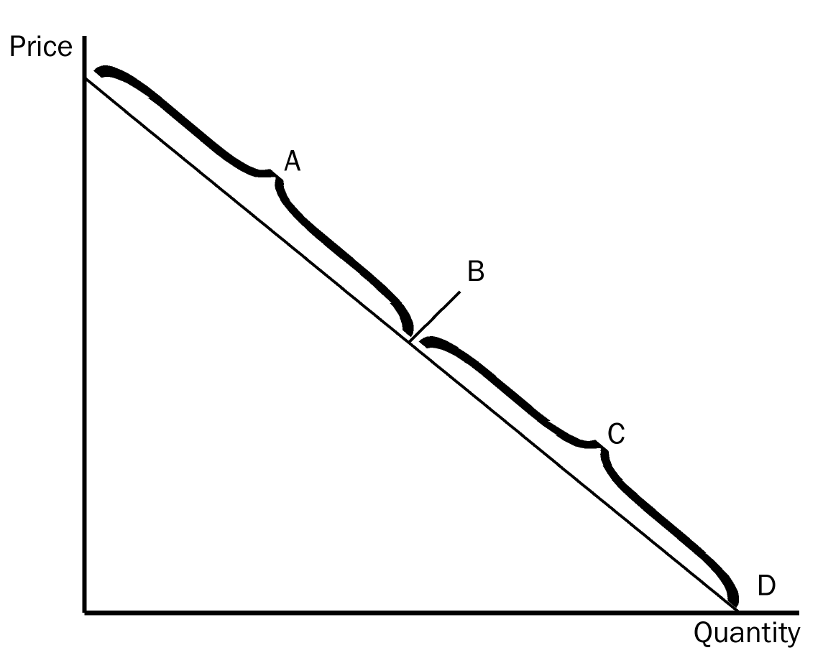
38. According to the graph, the section of the demand curve labeled A represents the
a. elastic section of the demand curve.
b. inelastic section of the demand curve.
c. unit elastic section of the demand curve.
d. perfectly elastic section of the demand curve.
ANSWER: a. elastic section of the demand curve.
TYPE: M SECTION: 1 DIFFICULTY: 2
39. According to the graph, the point on the demand curve labeled B represents the
a. elastic section of the demand curve.
b. inelastic section of the demand curve.
c. unit elastic section of the demand curve.
d. perfectly elastic section of the demand curve.
ANSWER: c. unit elastic section of the demand curve.
TYPE: M SECTION: 1 DIFFICULTY:2
40. According to the graph, the section of the demand curve labeled C represents the
a. elastic section of the demand curve.
b. perfectly elastic section of the demand curve.
c. unit elastic section of the demand curve.
d. inelastic section of the demand curve.
ANSWER: d. inelastic section of the demand curve.
TYPE: M SECTION: 1 DIFFICULTY:2

41. According to the graph, the elasticity of demand from point A to point B, using the midpoint method would be
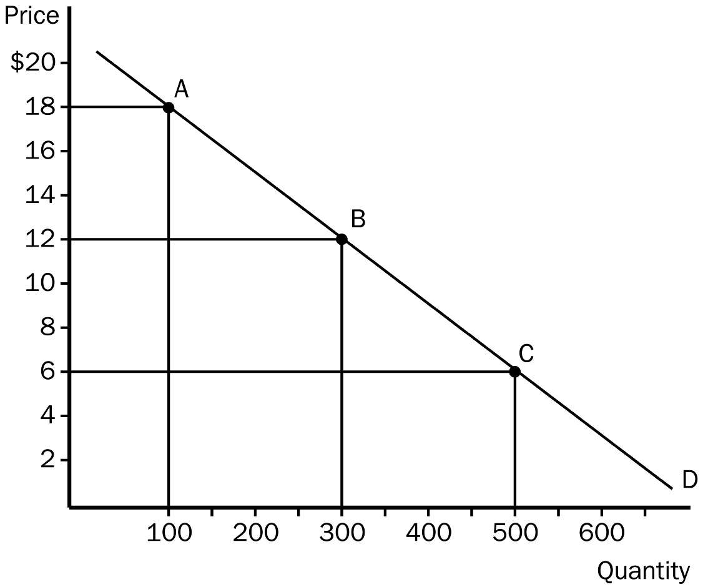
a. 1.
b. 1.5.
c. 2.
d. 2.5.
ANSWER: d. 2.5.
TYPE: M SECTION: 1 DIFFICULTY:2
42. According to the graph, the elasticity of demand from point B to point C, using the midpoint method would be
a. 0.5.
b. 0.75.
c. 1.0.
d. 1.3.
ANSWER: b. 0.75.
TYPE: M SECTION: 1 DIFFICULTY:2
43. According to the graph, if the price decreased from $18 to $6, what would happen to total revenue?
a. Total revenue would increase by $1200 and demand would be elastic.
b. Total revenue would increase by $800 and demand would be elastic.
c. Total revenue would decrease by $1200 and demand would be inelastic.
d. Total revenue would decrease by $800 and demand would be inelastic.
ANSWER: a. Total revenue would increase by $1200 and demand would be elastic.
TYPE: M SECTION: 1 DIFFICULTY: 3
44. When the price of kittens was $25 each, the pet shop sold 20 per month. When they raised the price to $35 each, they sold 14 per month. The elasticity of demand for kittens would be
a. 1.66.
b. 1.06.
c. 0.94.
d. 0.60.
ANSWER: b. 1.06.
TYPE: M SECTION: 1 DIFFICULTY: 3
45. When the local used bookstore prices economics books at $15.00 each, they generally sell 70 per month. If they lower the price to $7.00 each they sell 90. Given this, we know that the elasticity of demand for economics books is
a. 2.91, so this store should lower price to raise total revenue.
b. 2.91, so this store should raise price to raise total revenue.
c. 0.34, so this store should lower price to raise total revenue.
d. 0.34, so this store should raise price to raise total revenue.
ANSWER: d. 0.34, so this store should raise price to raise total revenue.
TYPE: M SECTION: 1 DIFFICULTY: 3
46. Demand is said to be inelastic if the
a. quantity demanded changes proportionately more than price.
b. price changes proportionately more than income.
c. quantity demanded changes proportionately less than price.
d. quantity demanded changes proportionately the same as price.
ANSWER: c. quantity demanded changes proportionately less than price.
TYPE: M SECTION: 1 DIFFICULTY: 2
47. Demand is said to be unit elastic if
a. quantity demanded changes by the same percent as the price.
b. quantity demanded changes by a larger percent than the price.
c. the demand curve shifts by the same percentage amount as the price.
d. quantity demanded does not respond to a change in price.
ANSWER: a. quantity demanded changes by the same percent as the price.
TYPE: M SECTION: 1 DIFFICULTY: 2
48. Elasticity of demand is closely related to the slope of the demand curve. The more responsive buyers are to a change in price, the demand curve will be
a. steeper.
b. further to the right.
c. flatter.
d. closer to the vertical axis.
ANSWER: c. flatter.
TYPE: M SECTION: 1 DIFFICULTY: 2
49. The flatter the demand curve through a given point, the
a. greater the price elasticity of demand.
b. smaller the price elasticity of demand.
c. closer the price elasticity of demand will be to the slope of the curve.
d. more equal the price elasticity of demand will be to the slope of the curve.
ANSWER: a. greater the price elasticity of demand.
TYPE: M SECTION: 1 DIFFICULTY: 3
50. A perfectly elastic demand implies that
a. buyers will not respond to any change in price.
b. any rise in price above that represented by the demand curve will result in no output demanded.
c. price and quantity demanded respond proportionally.
d. price will rise by an infinite amount when there is a change in quantity demanded.
ANSWER: b. any rise in price above that represented by the demand curve will result in no output demanded.
TYPE: M SECTION: 1 DIFFICULTY: 2
51. A perfectly elastic demand curve will be
a. vertical.
b. horizontal.
c. downward sloping to the right.
d. upward sloping to the right.
ANSWER: b. horizontal.
TYPE: M SECTION: 1 DIFFICULTY: 1
52. The smaller the price elasticity of demand the
a. closer the price elasticity of demand will be to the slope of the curve.
b. flatter the demand curve will be through a given point.
c. steeper the demand curve will be through a given point.
d. more equal the price elasticity of demand will be to the slope of the curve.
ANSWER: c. steeper the demand curve will be through a given point.
TYPE: M SECTION: 1 DIFFICULTY: 3
53. In the case of perfectly inelastic demand,
a. quantity demanded stays the same regardless of price changes.
b. huge changes in quantity demanded result from very small changes in the price.
c. the change in quantity demanded exactly equals the change in price.
d. the change in quantity demanded will be twice the change in price.
ANSWER: a. quantity demanded stays the same regardless of price changes.
TYPE: M SECTION: 1 DIFFICULTY: 3
54. A perfectly inelastic demand curve will be
a. negatively sloped, because buyers decrease their purchases when the price rises.
b. vertical, because buyers purchase the same amount whether the price rises or falls.
c. positively sloped, because buyers respond by increasing their purchases when price rises.
d. horizontal, because buyers increase their purchases by huge amounts with slight changes in price.
ANSWER: b. vertical, because buyers purchase the same amount whether the price rises or falls.
TYPE: M SECTION: 1 DIFFICULTY: 3
55. When small changes in price lead to infinite changes in quantity demanded, demand is perfectly
a. elastic and will be horizontal.
b. inelastic and will be horizontal.
c. elastic and will be vertical.
d. inelastic and will be vertical.
ANSWER: a. elastic and will be horizontal.
TYPE: M SECTION: 1 DIFFICULTY: 3
56. As elasticity of demand increases the demand curve gets
a. flatter and the price elasticity of demand will be less than 1.
b. steeper and the price elasticity of demand will be greater than 1.
c. flatter and the price elasticity of demand will be greater than 1.
d. steeper and the price elasticity of demand will be less than 1.
ANSWER: c. flatter and the price elasticity of demand will be greater than 1.
TYPE: M SECTION: 1 DIFFICULTY: 3
57. When quantity moves proportionally the same amount as price, demand is
a. relatively elastic and the price elasticity of demand is 1.
b. perfectly elastic and the price elasticity of demand is 1.
c. perfectly inelastic and the price elasticity of demand is less than 1.
d. unit elastic and the price elasticity of demand is 1.
ANSWER: d. unit elastic and the price elasticity of demand is 1.
TYPE: M SECTION: 1 DIFFICULTY: 3
58. When the price elasticity of demand is perfectly inelastic, the elasticity
a. is zero and the demand curve is vertical.
b. is zero and the demand curve is horizontal.
c. approaches infinity and the demand curve is vertical.
d. approaches infinity and the demand curve is horizontal.
ANSWER: a. is zero and the demand curve is vertical.
TYPE: M SECTION: 1 DIFFICULTY: 3
59. A perfectly inelastic demand implies that buyers
a. decrease their purchases when the price rises.
b. purchase the same amount when the price rises or falls.
c. increase their purchases only slightly when the price falls.
d. respond substantially to an increase in price.
ANSWER: b. purchase the same amount when the price rises or falls.
TYPE: M SECTION: 1 DIFFICULTY: 2
60. Alice says that she would buy one banana split a day regardless of the price. If she is telling the truth,
a. Alice’s demand for banana splits is perfectly inelastic.
b. Alice’s price elasticity of demand for banana splits is 1.
c. Alice’s income elasticity of demand for banana splits is negative.
d. None of the above answers is correct.
ANSWER: a. Alice’s demand for banana splits is perfectly inelastic.
TYPE: M SECTION: 1 DIFFICULTY: 2
61. Which of the following would have the most elastic demand?
a. clothing
b. blue jeans
c. Levi jeans
d. All three would have the same elasticity of demand since they are all related.
ANSWER: c. Levi jeans
TYPE: M SECTION: 1 DIFFICULTY: 2
62. In any market, total revenue is price
a. divided by the price elasticity of demand.
b. multiplied by quantity.
c. plus quantity.
d. multiplied by quantity minus the costs of production.
ANSWER: b. multiplied by quantity.
TYPE: M SECTION: 1 DIFFICULTY: 2
63. How does total revenue change as one moves down a linear demand curve?
a. It increases.
b. It decreases.
c. It first increases, then decreases.
d. It is unaffected by a movement along the demand curve.
ANSWER: c. It first increases, then decreases.
TYPE: M SECTION: 1 DIFFICULTY: 3
64. On a downward-sloping linear demand curve, total revenue would be at a maximum at the
a. midpoint of the demand curve.
b. lower end of the demand curve.
c. upper end of the demand curve.
d. It is impossible to tell without knowing prices and quantities demanded.
ANSWER: a. midpoint of the demand curve.
TYPE: M SECTION: 1 DIFFICULTY: 2
65. At the midpoint of a downward-sloping linear demand curve, price elasticity would be
a. inelastic.
b. elastic.
c. unit elastic.
d. perfectly elastic.
ANSWER: c. unit elastic.
TYPE: M SECTION: 1 DIFFICULTY: 2
66. A demand curve with a zero elasticity is perfectly
a. inelastic and vertical.
b. inelastic and horizontal.
c. elastic and vertical.
d. elastic and horizontal.
ANSWER: a. inelastic and vertical.
TYPE: M SECTION: 1 DIFFICULTY: 3
67. According to the graph, if price falls in the A range of the demand curve we can expect total revenue to
a. increase.
b. decrease.
c. stay the same.
d. decrease, then increase.
ANSWER: a. increase.
TYPE: M SECTION: 1 DIFFICULTY: 3
68. According to the graph, if price falls in the C range of the demand curve we can expect total revenue to
a. increase.
b. decrease.
c. stay the same.
d. decrease, then increase.
ANSWER: b. decrease.
TYPE: M SECTION: 1 DIFFICULTY: 3

69. According to the graph, as price falls from P_{A} to P_{B}, which demand curve is most elastic?
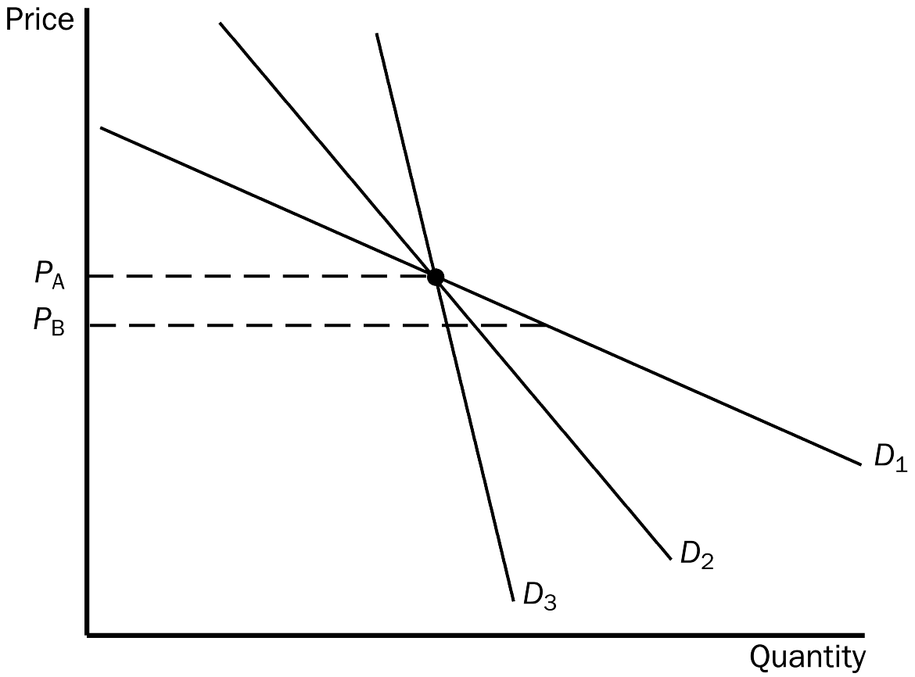
a. D₁
b. D₂
c. D₃
d. All of the above are equally elastic.
ANSWER: a. D₁
TYPE: M SECTION: 1 DIFFICULTY: 3
70. According to the graph, as price falls from P_{A} to P_{B}, which demand curve is least elastic?
a. D₁
b. D₂
c. D₃
d. All of the above are equally elastic.
ANSWER: c. D₃
TYPE: M SECTION: 1 DIFFICULTY: 3
71. When demand is inelastic, a decrease in price will cause
a. an increase in total revenue.
b. a decrease in total revenue.
c. no change in total revenue.
d. There is insufficient information to answer this question.
ANSWER: b. a decrease in total revenue.
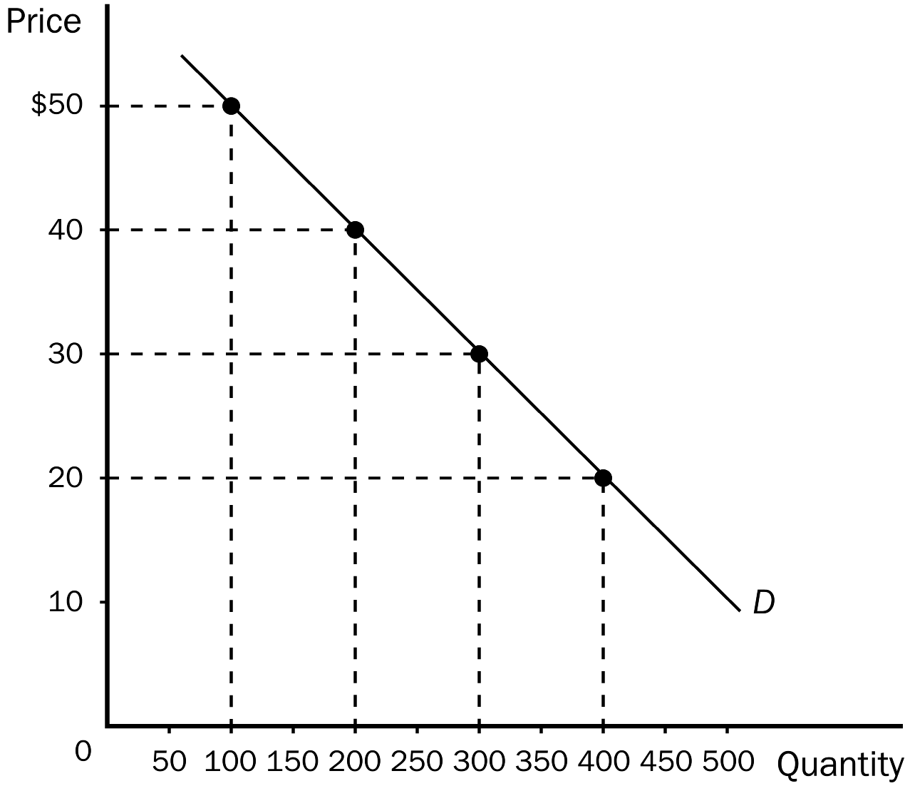
TYPE: M SECTION: 1 DIFFICULTY: 2
72. According to the graph, total revenue at a price of $30 would be
a. $9,000.
b. $7,000.
c. $5,000.
d. $3,000.
ANSWER: a. $9,000.
TYPE: M SECTION: 1 DIFFICULTY: 2
73. According to the graph, when price falls from point $40 to $30 we know that demand must be
a. elastic, since total revenue increases from $8000 to $9000.
b. inelastic, since total revenue increases from $8000 to $9000.
c. inelastic, since total revenue decreases from $9000 to $8000.
d. unit elastic, since total revenue decreases from $9000 to $8000.
ANSWER: a. elastic, since total revenue increases from $8000 to $9000.
TYPE: M SECTION: 1 DIFFICULTY: 3
74. According to the graph, lowering price from $30 to $20 would
a. increase total revenue by $2,000.
b. decrease total revenue by $2,000.
c. increase total revenue by $1,000.
d. decrease total revenue by $1,000.
ANSWER: d. decrease total revenue by $1,000.
TYPE: M SECTION: 1 DIFFICULTY: 3
75. An increase in price causes an increase in total revenue when
a. demand is elastic.
b. demand is inelastic.
c. demand is unit elastic.
d. All of the above are possible.
ANSWER: b. demand is inelastic.
TYPE: M SECTION: 1 DIFFICULTY: 2

76. According to the graph, if price increases from $10 to $15, total revenue will
a. increase by $20, so demand must be inelastic.
b. increase by $5, so demand must be inelastic.
c. decrease by $20, so demand must be elastic.
d. decrease by $10, so demand must be elastic.
ANSWER: a. increase by $20, so demand must be inelastic.
TYPE: M SECTION: 1 DIFFICULTY: 3
77. According to the graph, the price elasticity of this demand curve between $10 and $15 is
a. unit elastic.
b. elastic.
c. inelastic.
d. perfectly elastic.
ANSWER: c. inelastic.
TYPE: M SECTION: 1 DIFFICULTY: 3

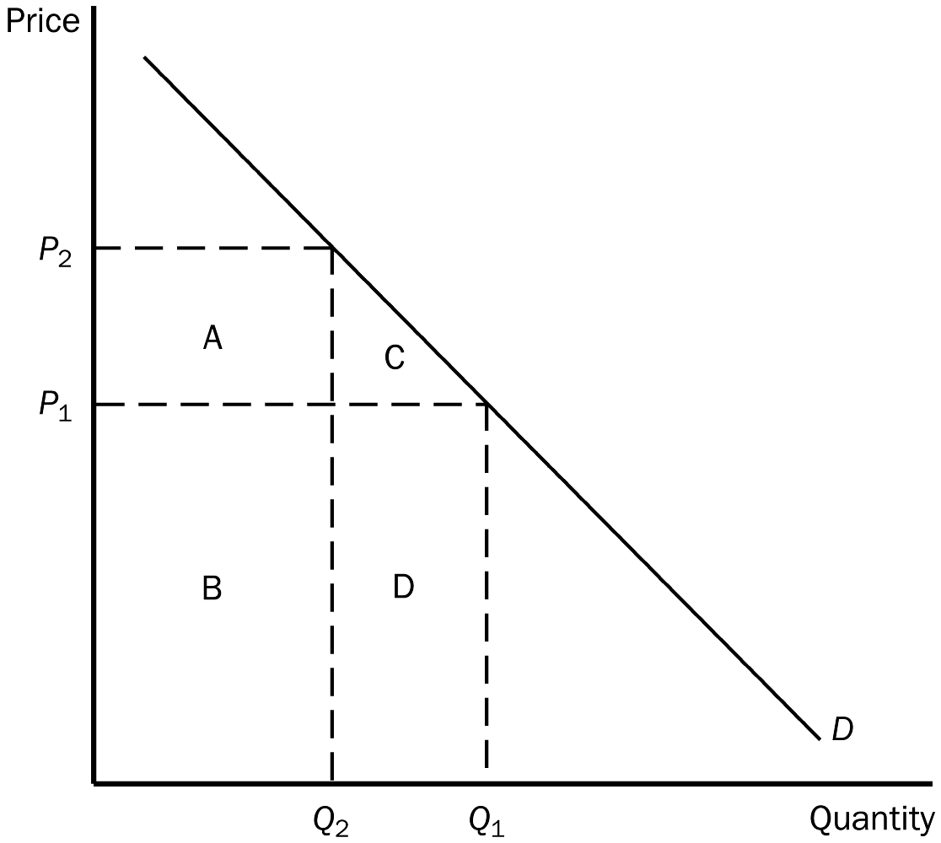
78. According to the graph, the total revenue at P1 is represented by area(s)
a. B + D.
b. A + B.
c. C + D.
d. D.
ANSWER: a. B + D.
TYPE: M SECTION: 1 DIFFICULTY: 2
79. According to the graph, total revenue at P2 would be represented by area(s)
a. B + D.
b. A + B.
c. C + D.
d. D.
ANSWER: b. A + B.
TYPE: M SECTION: 1 DIFFICULTY: 2
80. If the demand for donuts is elastic, a decrease in the price of donuts will
a. increase total revenue of donut sellers.
b. decrease total revenue of donut sellers.
c. not change total revenue of donut sellers.
d. There is not enough information to answer this question.
ANSWER: a. increase total revenue of donut sellers.
TYPE: M SECTION: 1 DIFFICULTY: 2
81. The local pizza restaurant makes such great bread sticks that consumers do not respond much to a change in the price. If the owner is only interested in increasing revenue, he should
a. lower the price of the bread sticks.
b. leave the price of the bread sticks alone.
c. raise the price of the bread sticks.
d. reduce costs.
ANSWER: c. raise the price of the bread sticks.
TYPE: M SECTION: 1 DIFFICULTY: 2
82. You produce jewelry boxes. If the demand for jewelry boxes is elastic and you want to increase your total revenue, you should
a. increase the price of your jewelry boxes.
b. decrease the price of your jewelry boxes.
c. not change the price of your jewelry boxes.
d. None of the above answers are correct.
ANSWER: b. decrease the price of your jewelry boxes.
TYPE: M SECTION: 1 DIFFICULTY: 2
83. When demand is elastic in the current price range,
a. an increase in price would increase total revenue because the decrease in quantity demanded is less than the increase in price.
b. an increase in price would decrease total revenue because the decrease in quantity demanded is greater than the increase in price.
c. a decrease in price would decrease total revenue because the increase in quantity demanded is smaller than the decrease in price.
d. a decrease in price would not affect the total revenue.
ANSWER: b. an increase in price would decrease total revenue because the decrease in quantity demanded is greater than the increase in price.
TYPE: M SECTION: 1 DIFFICULTY: 3
84. When demand is elastic the price elasticity is
a. greater than 1, and price and total revenue will move in opposite directions.
b. less than 1, and price and total revenue will move in the same direction.
c. less than 1, and price and total revenue will move in opposite directions.
d. greater than 1, and price and total revenue will move in the same direction.
ANSWER: a. greater than 1, and price and total revenue will move in opposite directions.
TYPE: M SECTION: 1 DIFFICULTY: 3
85. Holding all other forces constant, if raising the price of a good results in less total revenue, the demand for the good must be
a. unit elastic.
b. inelastic.
c. elastic.
d. perfectly inelastic.
ANSWER: c. elastic.
TYPE: M SECTION: 1 DIFFICULTY: 2
86. If a change in the price of a good results in no change in total revenue,
a. the demand for the good must be elastic.
b. the demand for the good must be inelastic.
c. the demand for the good must be unit elastic.
d. buyers must not respond very much to a change in price.
ANSWER: c. the demand for the good must be unit elastic.
TYPE: M SECTION: 1 DIFFICULTY: 2
87. When demand is unit elastic price elasticity
a. exactly equals 1 and total revenue does not change when price changes.
b. exactly equals 1 and total revenue and price move in opposite directions.
c. exactly equals 1 and total revenue and price move in the same direction.
d. approaches infinity and total revenue does not change when price changes.
ANSWER: a. exactly equals 1 and total revenue does not change when price changes.
TYPE: M SECTION: 1 DIFFICULTY: 3
88. If the demand curve is linear and downward sloping, which of the following would NOT be correct?
a. The upper part of the demand curve is more elastic than the lower part.
b. Elasticity will change with a movement down the curve.
c. The lower part of the demand curve would be less elastic than the upper part.
d. Slope will change with a movement down the curve.
ANSWER: d. Slope will change with a movement down the curve.
TYPE: M SECTION: 1 DIFFICULTY: 3
89. For a vertical demand curve, slope
a. is undefined and elasticity equals 0.
b. equals 0 and elasticity is undefined.
c. and elasticity are both undefined.
d. and elasticity are both equal to 0.
ANSWER: a. is undefined and elasticity equals 0.
TYPE: M SECTION: 1 DIFFICULTY: 3
90. For a horizontal demand curve, slope
a. is undefined and elasticity equals 0.
b. equals 0 and elasticity is undefined.
c. and elasticity are both undefined.
d. and elasticity are both equal to 0.
ANSWER: b. equals 0 and elasticity is undefined.
TYPE: M SECTION: 1 DIFFICULTY: 3
91. Along a linear demand curve, slope
a. and elasticity are both constant.
b. changes but elasticity is constant.
c. and elasticity both change.
d. is constant but elasticity changes.
ANSWER: d. is constant but elasticity changes.
TYPE: M SECTION: 1 DIFFICULTY: 3
92. Moving down a linear demand curve we know that elasticity gets
a. smaller, then larger.
b. larger.
c. smaller.
d. larger, then smaller.
ANSWER: c. smaller.
TYPE: M SECTION: 1 DIFFICULTY: 2
93. Moving up a linear demand curve, we know that total revenue
a. increases, then decreases.
b. decreases, then increases.
c. increases.
d. decreases.
ANSWER: a. increases, then decreases.
TYPE: M SECTION: 1 DIFFICULTY: 3
94. Total revenue will be highest on a linear demand curve at
a. the top of the curve where prices are higher.
b. the center of the curve.
c. the lower end of the curve where quantity is higher.
d. any point on the curve, total revenue will be the same since increases in price are offset by decreases in quantity.
ANSWER: b. the center of the curve.
TYPE: M SECTION: 1 DIFFICULTY: 2
95. Suppose that 50 candy bars are demanded at a particular price. If the price of candy bars rises by 4 percent, the number of candy bars demanded falls to 46 candy bars. According to the midpoint method, this means that the
a. demand for candy bars in this price range is elastic.
b. demand for candy bars in this price range is inelastic.
c. price elasticity of demand for candy bars is 0.
d. demand for candy bars is unit elastic.
ANSWER: a. demand for candy bars in this price range is elastic.
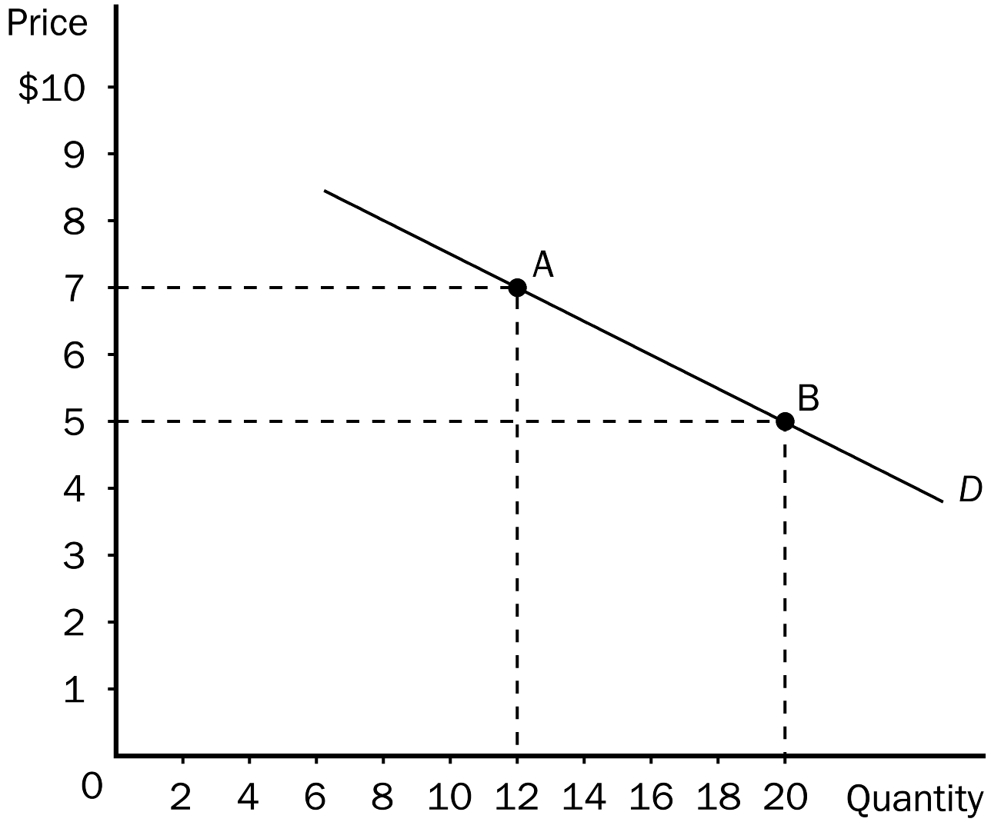
TYPE: M SECTION: 1 DIFFICULTY: 3
96. According to the graph, between point A and point B we know that
a. the slope is equal to 1/4 and elasticity is equal to 2/3.
b. the slope is equal to 1/4 and elasticity is equal to 3/2.
c. the slope is equal to 3/2 and elasticity is equal to 1/4.
d. the slope is equal to 2/3 and elasticity is equal to 1/4.
ANSWER: b. the slope is equal to 1/4 and elasticity is equal to 3/2.
TYPE: M SECTION: 1 DIFFICULTY: 3
97. Between point A and point B on the graph, the elasticity of demand is
a. perfectly elastic.
b. inelastic.
c. unit elastic.
d. elastic.
ANSWER: d. elastic.
TYPE: M SECTION: 1 DIFFICULTY: 2
98. Which pair of products lists the more elastic product first?
a. corn oil and motor oil
b. eggs and butter
c. erasers and Snickers candy bars
d. car tires and diet Coke
ANSWER: a. corn oil and motor oil
TYPE: M SECTION: 1 DIFFICULTY: 2
99. The elasticity of demand will change along
a. a horizontal demand curve.
b. a vertical demand curve.
c. a linear, downward-sloping demand curve.
d. the elasticity of demand remains constant along all demand curves.
ANSWER: c. a linear, downward-sloping demand curve.
TYPE: M SECTION: 1 DIFFICULTY: 2
100. The difference between slope and elasticity is that
a. slope measures actual changes and elasticity measures percentage changes.
b. slope measures percentage changes and elasticity measures actual changes.
c. slope measures changes in quantity demanded more accurately than elasticity.
d. there is no difference between slope and elasticity calculations.
ANSWER: a. slope measures actual changes and elasticity measures percentage changes.
TYPE: M SECTION: 1 DIFFICULTY: 2
101. Which of the following would probably have the most inelastic demand?
a. cigarettes
b. insulin
c. apples
d. paper towels
ANSWER: b. insulin
TYPE: M SECTION: 1 DIFFICULTY: 1
102. Whether a good is a luxury or necessity depends on
a. the price of the good.
b. the preferences of the buyer.
c. the intrinsic properties of the good.
d. how scarce the good is.
ANSWER: b. the preferences of the buyer.
TYPE: M SECTION: 1 DIFFICULTY: 2
103. Last year, Sheila bought 6 pairs of shoes when her income was $40,000. This year, her income is $50,000 and she purchased 10 pairs of shoes. All else constant, it is obvious that Sheila
a. prefers shoes to boots.
b. considers shoes to be an inferior good.
c. considers shoes to be a normal good.
d. has a price-inelastic demand for shoes.
ANSWER: c. considers shoes to be a normal good.
TYPE: M SECTION: 1 DIFFICULTY: 2
104. When the rental price of DVD movies is $4, Denise rents five per month. When the price is $3, she rents nine per month. Denise’s demand for DVD rentals is
a. elastic and the curve would be relatively flat.
b. elastic and the curve would be relatively steep.
c. inelastic and the curve would be relatively flat.
d. inelastic and the curve would be relatively steep.
ANSWER: a. elastic and the curve would be relatively flat.
TYPE: M SECTION: 1 DIFFICULTY: 3
105. Your younger sister needs $50 to buy a new bike. She has opened a lemonade stand to make the money she needs. She currently is charging 25 cents per cup, but wants to adjust her price to earn the money faster. If you know that the demand for lemonade is elastic, what is your advice to her?
a. Leave the price the same and be patient.
b. Raise the price to increase total revenue.
c. Lower the price to increase total revenue.
d. There isn’t enough information given to answer this question.
ANSWER: c. Lower the price to increase total revenue.
TYPE: M SECTION: 1 DIFFICULTY: 2
106. The Winston/Calfee study conducted to determine how to increase revenue from the Greenway toll road found that commuters would only be willing to pay a $2 toll if they
a. could save 20 minutes in commute time.
b. earned at least $30 an hour.
c. commuted at least 40 miles to work.
d. had a low tolerance for public transportation.
ANSWER: b. earned at least $30 an hour.
TYPE: M SECTION: 1 DIFFICULTY: 1
107. The Winston/Calfee study determined that the toll they charged commuters of the Greenway toll road was
a. too high, and if lowered, would increase total revenue.
b. too low, and if raised, would increase total revenue.
c. appropriate, since it yielded maximum revenue.
d. just enough to keep the road from rush hour congestion.
ANSWER: a. too high, and if lowered, would increase total revenue.
TYPE: M SECTION: 1 DIFFICULTY: 2
108. The Winston/Calfee study on the Greenway toll road found that the elasticity of demand was
a. inelastic, and total revenue could be raised if the toll was raised.
b. elastic, and total revenue could be raised if the toll was raised.
c. inelastic, and total revenue could be raised if the toll was lowered.
d. elastic, and total revenue could be raised if the toll was lowered.
ANSWER: d. elastic, and total revenue could be raised if the toll was lowered.
TYPE: M SECTION: 1 DIFFICULTY: 2
109. Income elasticity of demand measures how
a. the quantity demanded changes as consumer income changes.
b. consumer purchasing power is affected by a change in the price of a good.
c. the price of a good is affected when there is a change in consumer income.
d. many units of a good a consumer can buy given a certain income level.
ANSWER: a. the quantity demanded changes as consumer income changes.
TYPE: M SECTION: 1 DIFFICULTY: 2
110. If a 6 percent increase in income results in a 10 percent increase in the quantity demanded of pizza, then the income elasticity of demand for pizza is
a. negative and therefore pizza is an normal good.
b. negative and therefore pizza is a inferior good.
c. positive and therefore pizza is an inferior good.
d. positive and therefore pizza is a normal good.
ANSWER: d. positive and therefore pizza is a normal good.
TYPE: M SECTION: 1 DIFFICULTY:2
111. Which of the following would you expect to have the highest income elasticity of demand?
a. water
b. diamonds
c. hamburgers
d. housing
ANSWER: b. diamonds
TYPE: M SECTION: 1 DIFFICULTY: 1
112. Last year, Joan bought 50 pounds of hamburger when the household income was $40,000. This year, the household income was only $30,000 and Joan bought 60 pounds of hamburger. All else constant Joan’s income elasticity of demand for hamburger is
a. positive, so Joan considers hamburger to be an inferior good.
b. positive, so Joan considers hamburger to be a normal good and a necessity.
c. negative, so Joan considers hamburger to be an inferior good.
d. negative, so Joan considers hamburger to be a normal good.
ANSWER: c. negative, so Joan considers hamburger to be an inferior good.
TYPE: M SECTION: 4 DIFFICULTY: 2
113. If an increase in income results in a decrease in the quantity demanded of a good, then the good is
a. an inferior good.
b. a necessity.
c. a normal good.
d. a luxury.
ANSWER: a. an inferior good.
TYPE: M SECTION: 1 DIFFICULTY: 1
114. To determine whether a good is considered normal or inferior, one would consider the good’s
a. income elasticity of demand.
b. price elasticity of demand.
c. price elasticity of supply.
d. cross-price elasticity of demand.
ANSWER: a. income elasticity of demand.
TYPE: M SECTION: 1 DIFFICULTY: 1
115. You and your college roommate eat three packages of Ramen noodles each week. After graduation last month, both of you were hired at several times your college income. You still enjoy Ramen noodles very much and buy even more, but your roommate plans to buy other foods she prefers more. When looking at income elasticity of demand for Ramen noodles, yours would
a. be negative and your roommate’s would be positive.
b. be positive and your roommate’s would be negative.
c. be zero and your roommate’s would approach infinity.
d. approach infinity and your roommate’s would be zero.
ANSWER: b. be positive and your roommate’s would be negative.
TYPE: M SECTION: 1 DIFFICULTY: 2
116. Suppose that good X has a negative income elasticity of demand. This implies that the good is
a. a normal good.
b. a necessity.
c. an inferior good.
d. a luxury.
ANSWER: c. an inferior good.
TYPE: M SECTION: 1 DIFFICULTY: 1
117. Which of the following would have a large income elasticity?
a. luxuries
b. necessities
c. substitutes
d. complements
ANSWER: a. luxuries
TYPE: M SECTION: 1 DIFFICULTY: 1
118. Assume that a 4 percent increase in income results in a 2 percent increase in the quantity demanded of a good. The income elasticity of demand for the good is
a. negative and therefore the good is an inferior good.
b. negative and therefore the good is a normal good.
c. positive and therefore the good is a normal good.
d. positive and therefore the good is an inferior good.
ANSWER: c. positive and therefore the good is a normal good.
TYPE: M SECTION: 1 DIFFICULTY: 2
119. Assume that a 4 percent increase in income results in a 6 percent decrease in the quantity demanded of a good. The income elasticity of demand for the good is
a. negative and therefore the good is an inferior good.
b. negative and therefore the good is a normal good.
c. positive and therefore the good is an inferior good.
d. positive and therefore the good is a normal good.
ANSWER: a. negative and therefore the good is an inferior good.
TYPE: M SECTION: 1 DIFFICULTY: 2
Income | Quantity of Good X  Purchased | Quantity of Good y  Purchased
$30,000 | 2 | 20
$40,000 | 5 | 10

120. According to the table, using the midpoint method, what is the income elasticity of good Y?
a. –3.33
b. –2.33
c. 1.33
d. 2.33
ANSWER: b.–2.33
TYPE: M SECTION: 1 DIFFICULTY: 3
121. According to the table, Good X is
a. very price elastic.
b. an inferior good.
c. underpriced.
d. a normal good.
ANSWER: d. a normal good.
TYPE: M SECTION: 1 DIFFICULTY: 1
122. According to the table, Good Y is
a. not related to income.
b. an inferior good.
c. price inelastic.
d. a normal good.
ANSWER: b. an inferior good.
TYPE: M SECTION: 1 DIFFICULTY: 2
123. Cross-price elasticity of demand measures how the
a. quantity demanded of a good changes as price changes.
b. quantity demanded of a good changes as income changes.
c. quantity demanded of one good changes as the price of another good changes.
d. price of a good is affected when income changes.
ANSWER: c. quantity demanded of one good changes as the price of another good changes.
TYPE: M SECTION: 1 DIFFICULTY: 1
124. The cross-price elasticity of demand can tell us whether goods are
a. normal or inferior.
b. elastic or inelastic.
c. luxuries or necessities.
d. complements or substitutes.
ANSWER: d. complements or substitutes.
TYPE: M SECTION: 1 DIFFICULTY: 2
125. Cross-price elasticity of demand is calculated as the
a. percentage change in quantity demanded of good 1 divided by the percentage change in the price of good 2.
b. total percentage change in quantity demanded divided by the total percentage change in price.
c. percentage change in quantity demanded divided by the percentage change in income.
d. percentage change in the price of good 1 divided by the percentage change in the price of good 2.
ANSWER: a. percentage change in quantity demanded of good 1 divided by the percentage change in the price of good 2.
TYPE: M SECTION: 1 DIFFICULTY: 2
126. If the cross-price elasticity of two goods is negative, then those two goods are
a. substitutes.
b. complements.
c. normal goods.
d. inferior goods.
ANSWER: b. complements.
TYPE: M SECTION: 1 DIFFICULTY: 1
127. If two goods are substitutes, their cross-price elasticity will be
a. positive.
b. negative.
c. zero.
d. 1.
ANSWER: a. positive.
TYPE: M SECTION: 1 DIFFICULTY: 1
128. If the cross-price elasticity of demand is 1.25, then the two goods would be
a. complements.
b. luxuries.
c. normal goods.
d. substitutes.
ANSWER: d. substitutes.
TYPE: M SECTION: 1 DIFFICULTY: 1
129. Food and clothing tend to have
a. small income elasticities because consumers, regardless of their incomes, choose to buy these goods.
b. small income elasticities because consumers will buy proportionately more at higher income levels than they will at low income levels.
c. large income elasticities because they are necessities.
d. large income elasticities because they are relatively cheap.
ANSWER: a. small income elasticities because consumers, regardless of their incomes, choose to buy these goods.
TYPE: M SECTION: 1 DIFFICULTY: 3
130. If you want to know how an increase in the price of ice cream at the next door Ice Cream Shoppe affects the demand for frozen yogurt in your shop you would compute the
a. price elasticity of demand.
b. income elasticity of demand.
c. cross-price elasticity of demand.
d. price elasticity of supply.
ANSWER: c. cross-price elasticity of demand.
TYPE: M SECTION: 1 DIFFICULTY: 2
131. The demand for caviar tends to be income
a. elastic because it is relatively expensive.
b. inelastic because it is packaged in small containers.
c. elastic because buyers generally feel that they can do without it.
d. inelastic because it is scarce.
ANSWER: c. elastic because buyers generally feel that they can do without it.
TYPE: M SECTION: 1 DIFFICULTY: 1
132. Suppose the government increases the tax on gasoline in order to raise revenue. Since raising the gasoline tax would increase the price of gasoline, the government must be assuming that the
a. demand for gasoline is price elastic.
b. demand for gasoline is price inelastic.
c. demand for gasoline is price unit-elastic.
d. tax on gasoline will not affect the consumption of gasoline.
ANSWER: b. demand for gasoline is price inelastic.
TYPE: M SECTION: 1 DIFFICULTY: 2
133. Suppose the price elasticity of demand for basketballs is 1.20. A 15 percent increase in price will result in
a. an 18 percent decrease in the quantity of basketballs demanded.
b. a 15 percent decrease in the quantity of basketballs demanded.
c. an 8 percent reduction in the number of basketballs demanded.
d. a 12.5 percent reduction in the number of basketballs demanded.
ANSWER: a. an 18 percent decrease in the quantity of basketballs demanded.
TYPE: M SECTION: 1 DIFFICULTY: 3
134. Get Smart University is contemplating increasing tuition to enhance revenue. If GSU feels that raising tuition would enhance revenue, they are
a. necessarily ignoring the law of demand.
b. assuming that the demand for university education is elastic.
c. assuming that the demand for university education is inelastic.
d. assuming that the supply of university education is elastic.
ANSWER: c. assuming that the demand for university education is inelastic.
TYPE: M SECTION: 1 DIFFICULTY: 3
135. The price elasticity of supply measures how much
a. the quantity supplied responds to changes in input prices.
b. the quantity supplied responds to changes in the price of the good.
c. the price of the good responds to changes in supply.
d. sellers respond to changes in technology.
ANSWER: b. the quantity supplied responds to changes in the price of the good.
TYPE: M SECTION: 2 DIFFICULTY: 2
136. The price elasticity of supply measures how responsive
a. sellers are to a change in price.
b. buyers are to a change in income.
c. buyers are to a change in price.
d. sellers are to a change in buyers’ income.
ANSWER: a. sellers are to a change in price.
TYPE: M SECTION: 2 DIFFICULTY: 1
137. A key determinant of the elasticity of supply is
a. the ability of sellers to change the price of the good they produce.
b. the number of firms in the market.
c. how responsive buyers are to changes in sellers’ prices.
d. the ability of sellers to change the amount of the good they produce.
ANSWER: d. the ability of sellers to change the amount of the good they produce.
TYPE: M SECTION: 2 DIFFICULTY: 2
138. In the short run, the quantity supplied is
a. very responsive to price changes.
b. not very responsive to price changes.
c. indifferent to price changes.
d. totally responsive to price changes.
ANSWER: b. not very responsive to price changes.
TYPE: M SECTION: 2 DIFFICULTY: 1
139. In the long run which of the following would NOT be a reason why the elasticity of supply is elastic?
a. Firms can build new factories.
b. Firms can hire additional workers.
c. New firms can enter the market.
d. Firms can sell less at lower prices without losing profits.
ANSWER: d. Firms can sell less at lower prices without losing profits.
TYPE: M SECTION: 2 DIFFICULTY: 2
140. Holding all else constant, if a pencil manufacturer increases production by 20 percent when the market price of pencils increases from $0.50 to $0.60, then the price elasticity of supply, using the midpoint method, must be
a. elastic, since elasticity is equal to 1.11.
b. inelastic, since elasticity is equal to 1.11.
c. inelastic, since elasticity is equal to .90.
d. elastic, since elasticity is equal to .90.
ANSWER: a. elastic, since elasticity is equal to 1.11.
TYPE: M SECTION: 2 DIFFICULTY: 3
141. If sellers respond substantially to changes in price, then
a. the supply curve will shift substantially when the price rises.
b. sellers are considered to be relatively price insensitive.
c. sellers are considered to be relatively price sensitive.
d. the price elasticity of supply equals 1.
ANSWER: c. sellers are considered to be relatively price sensitive.
TYPE: M SECTION: 2 DIFFICULTY: 2
142. If the quantity supplied responds only slightly to changes in price, then
a. supply is said to be elastic.
b. increases in supply resulting from an increase in price will not shift the supply curve very much.
c. supply is said to be inelastic.
d. supply is said to be unit elastic.
ANSWER: c. supply is said to be inelastic.
TYPE: M SECTION: 2 DIFFICULTY: 2
143. The main determinant of the price elasticity of supply is
a. time.
b. the definition of the market.
c. the number of close substitutes.
d. luxuries vs. necessities.
ANSWER: a. time.
TYPE: M SECTION: 2 DIFFICULTY: 2
144. The supply of a good will be more elastic the
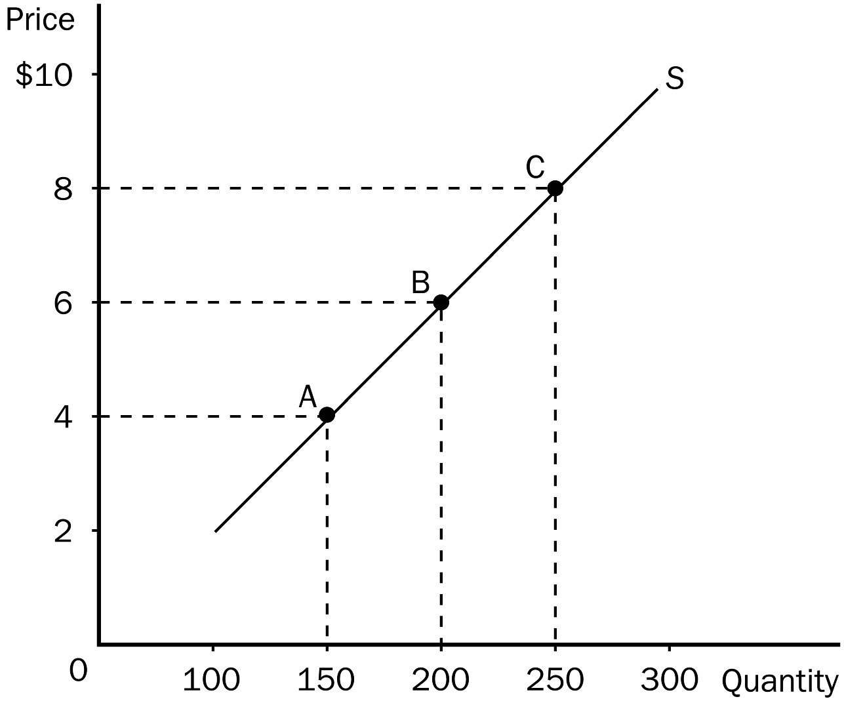
a. more the good is considered a luxury.
b. broader the market is defined.
c. more close substitutes the good has.
d. longer the time period being considered.
ANSWER: d. longer the time period being considered.
TYPE: M SECTION: 2 DIFFICULTY: 2
145. On the graph shown, the elasticity of supply from point A to point C, using the midpoint method would be approximately
a. 2.67.
b. 1.33.
c. 0.75.
d. 0.375.
ANSWER: c. 0.75.
TYPE: M SECTION: 1 DIFFICULTY: 3
146. Suppose that an increase in the price of carrots from $1.20 to $1.40 per pound raises the amount of carrots that carrot farmers produce from 1.2 million pounds to 1.6 million pounds. Using the midpoint method, what would be the elasticity of supply?
a. 2.00
b. 1.86
c. 0.54
d. 0.50
ANSWER: b. 1.86
TYPE: M SECTION: 2 DIFFICULTY: 3
147. An increase in the price of pure chocolate morsels from $2.25 to $2.45 causes Nestle to increase production from 125 bags per minute to 145 bags per minute. We know that the elasticity of supply is
a. elastic and equal to 1.74.
b. elastic and equal to 0.57.
c. inelastic and equal to 0.57.
d. inelastic and equal to 1.74.
ANSWER: a. elastic and equal to 1.74.
TYPE: M SECTION: 2 DIFFICULTY: 3
148. If a 30 percent change in price causes a 15percent change in quantity supplied, then the price elasticity of supply is
a. 1/2 and supply is elastic.
b. 1/2 and supply is inelastic.
c. 2 and supply is inelastic.
d. 2 and supply is elastic.
ANSWER: b. 1/2 and supply is inelastic.
TYPE: M SECTION: 2 DIFFICULTY: 3
149. In the long run, the quantity supplied of most goods
a. cannot respond at all to a change in price.
b. cannot respond much to a change in price.
c. can respond substantially to a change in price.
d. will naturally increase regardless of what happens to price.
ANSWER: c. can respond substantially to a change in price.
TYPE: M SECTION: 2 DIFFICULTY: 2
150. When a supply curve is relatively flat,
a. the supply is relatively elastic.
b. the supply is relatively inelastic.
c. sellers are not at all responsive to a change in price.
d. quantity supplied changes slightly when the price changes.
ANSWER: a. the supply is relatively elastic.
TYPE: M SECTION: 2 DIFFICULTY: 2
151. If sellers do not respond at all to a change in price,
a. technological advancement must be great.
b. supply must be perfectly elastic.
c. a long period of time must have elapsed.
d. supply must be perfectly inelastic.
ANSWER: d. supply must be perfectly inelastic.
TYPE: M SECTION: 2 DIFFICULTY: 2
152. If an increase in the price of a good results in an increase in total revenue for the firm, then the supply of the good must be
a. unit elastic.
b. inelastic.
c. elastic.
d. Nothing can be said about price elasticity of supply from the information given.
ANSWER: d. Nothing can be said about price elasticity of supply from the information given.
TYPE: M SECTION: 2 DIFFICULTY: 3
153. If the elasticity of supply of a product is greater than 1, then supply is
a. inelastic.
b. elastic.
c. unit elastic.
d. not very sensitive to change in price.
ANSWER: b. elastic.
TYPE: M SECTION: 2 DIFFICULTY: 2
154. As elasticity rises
a. the supply curve gets flatter.
b. the supply curve gets steeper.
c. quantity supplied responds less to a change in price.
d. elasticity gets closer to zero.
ANSWER: a. the supply curve gets flatter.
TYPE: M SECTION: 2 DIFFICULTY: 2
155. If the elasticity of supply is zero, then
a. supply is very elastic.
b. the supply curve is horizontal.
c. the quantity supplied is the same regardless of price.
d. Both b and c are correct.
ANSWER: c. the quantity supplied is the same regardless of price.
TYPE: M SECTION: 2 DIFFICULTY: 2
156. If two supply curves pass through the same point and one is steep and the other is flat, which of the following would be correct?
a. The flatter supply curve is more inelastic.
b. The steeper supply curve is more inelastic.
c. The elasticity of supply will be the same for both curves.
d. It is impossible to tell the elasticity of supply for either curve unless you are given actual numbers to compute the elasticity of both curves.
ANSWER: b. The steeper supply curve is more inelastic.
TYPE: M SECTION: 2 DIFFICULTY: 3
157. Which of the following is true concerning a vertical supply curve?
a. Suppliers will not respond to a change in price.
b. An infinite quantity will be supplied at a given price.
c. Suppliers will refuse to sell the product at the current market price.
d. If the price of the product increases, quantity supplied will increase substantially.
ANSWER: a. Suppliers will not respond to a change in price.
TYPE: M SECTION: 2 DIFFICULTY: 2
158. If the elasticity of supply of a product is 2.5, we know that supply is
a. inelastic.
b. elastic.
c. unit elastic.
d. perfectly inelastic.
ANSWER: b. elastic.
TYPE: M SECTION: 2 DIFFICULTY: 2
159. Which of the following would NOT be true of a perfectly elastic supply curve?
a. The elasticity of supply approaches infinity.
b. The supply curve is horizontal.
c. Very small changes in price lead to large changes in quantity supplied.
d. The firm would likely be operating in the short run.
ANSWER: d. The firm would likely be operating in the short run.
TYPE: M SECTION: 2 DIFFICULTY: 3
160. A linear supply curve has a
a. constant slope and changing elasticity of supply.
b. changing slope and a constant elasticity of supply.
c. both a constant slope and a constant elasticity of supply.
d. both a changing slope and a changing elasticity of supply.
ANSWER: a. constant slope and changing elasticity of supply.
TYPE: M SECTION: 2 DIFFICULTY: 3
161. If the quantity supplied is the same regardless of price, then the supply curve would be
a. elastic.
b. perfectly elastic.
c. perfectly inelastic.
d. inelastic.
ANSWER: c. perfectly inelastic.
TYPE: M SECTION: 2 DIFFICULTY: 1
162. The elasticity of a perfectly elastic supply curve equals
a. 0.
b. 1.
c. infinity.
d. less than 1 but greater than 0.
ANSWER: c. infinity.
TYPE: M SECTION: 2 DIFFICULTY: 1
163. As elasticity rises, the supply curve gets
a. flatter.
b. steeper.
c. vertical.
d. downward sloping.
ANSWER: a. flatter.
TYPE: M SECTION: 2 DIFFICULTY: 2
164. Which of the following would be true as the elasticity of supply approaches infinity?
a. Very small changes in price will lead to very large changes in quantity supplied.
b. Very large changes in price will lead to very small changes in quantity supplied.
c. Very small changes in price will lead to no change in quantity supplied.
d. Very large changes in price will lead to no change in quantity supplied.
ANSWER: a. Very small changes in price will lead to very large changes in quantity supplied.
TYPE: M SECTION: 2 DIFFICULTY: 3
165. Some firms experience elastic supply curves at low levels of quantity supplied and more inelastic supply curves at higher levels of quantity supplied because
a. at low levels of quantity supplied, firms have idle capacity.
b. at high levels of quantity supplied, firms incur higher production costs.
c. as low levels of quantity supplied, per unit production costs are less than at high levels of quantity supplied.
d. Both a and b are correct.
e. Both a and c are correct.
ANSWER: d. Both a and b are correct.
TYPE: M SECTION: 2 DIFFICULTY: 3
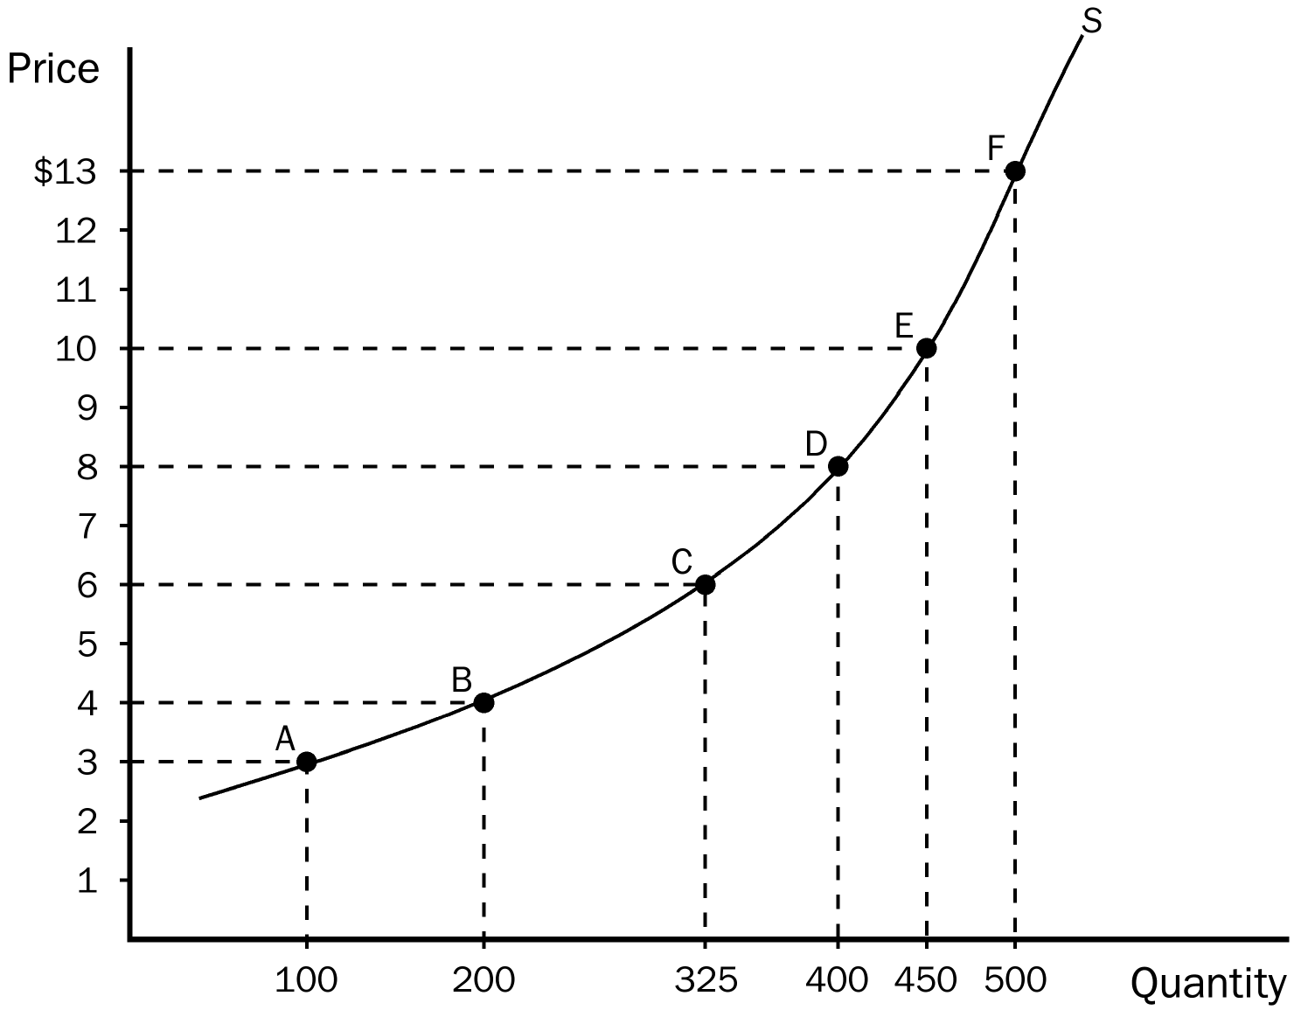
166. According to the graph, which of the following would be most inelastic?
a. from E to F
b. from C to D
c. from A to B
d. from A to C
ANSWER: a. from E to F
TYPE: M SECTION: 2 DIFFICULTY: 2
167. According to the graph, which of the following would be most elastic?
a. from A to B
b. from C to D
c. from E to F
d. from D to F
ANSWER: a. from A to B
TYPE: M SECTION: 2 DIFFICULTY: 2
168. According to the graph, what is the elasticity of supply between points D and E?
a. 1.89
b. 1.26
c. 0.53
d. 0.34
ANSWER: c. 0.53 TYPE: M SECTION: 2 DIFFICULTY: 3
169. Generally, a firm would be able to respond most to a change in price in
a. one month.
b. six months.
c. one year.
d. five years.
ANSWER: d. five years.
TYPE: M SECTION: 2 DIFFICULTY: 1

 | Supply Curve A | Supply Curve B | Supply Curve C

Price | $1.00 | $2.00 | $1.00 | $3.00 | $2.00 | $5.00
Quantity  Supplied | 500 | 600 | 600 | 900 | 400 | 700

170. According to the table, which of the following would represent a more inelastic supply curve?
a. supply curve A
b. supply curve B
c. supply curve C
d. There is no difference in the elasticity of the 3 supply curves.
ANSWER: a. supply curve A.
TYPE: M SECTION: 2 DIFFICULTY: 3
171. The discovery of a new hybrid wheat would tend to increase the supply of wheat. Under what conditions would wheat farmers realize an increase in revenue?
a. if the supply of wheat is elastic
b. if the supply of wheat is inelastic
c. if the demand for wheat is inelastic
d. if the demand for wheat is elastic
ANSWER: d. if the demand for wheat is elastic
TYPE: M SECTION: 3 DIFFICULTY: 3
172. Because the demand for wheat tends to be inelastic, the development of a new, more productive hybrid wheat would tend to
a. increase the total revenue of wheat farmers.
b. decrease the total revenue of wheat farmers.
c. weaken the demand for wheat.
d. weaken the supply of wheat.
ANSWER: b. decrease the total revenue of wheat farmers.
TYPE: M SECTION: 3 DIFFICULTY: 2
173. Knowing that the demand for wheat is inelastic, if all farmers voluntarily plowed under 10 percent of their wheat crop, then
a. consumers of wheat would buy more wheat.
b. wheat farmers would suffer a reduction in their revenue.
c. wheat farmers would increase their revenue.
d. the demand for wheat would decrease.
ANSWER: c. wheat farmers would increase their revenue.
TYPE: M SECTION: 3 DIFFICULTY: 2
174. The discovery of a new hybrid wheat can lower farmers’ revenue because the
a. demand for wheat is inelastic.
b. demand for wheat is elastic.
c. supply of wheat is elastic.
d. supply of wheat is inelastic.
ANSWER: a. demand for wheat is inelastic.
TYPE: M SECTION: 3 DIFFICULTY: 2
175. If wheat farmers know that the demand for wheat is inelastic, and they want to increase their total revenue, they should all
a. plant more wheat so that they would be able to sell more each year.
b. increase spending on fertilizer in an attempt to produce more on the acres they farm.
c. reduce the number of acres they plant in wheat.
d. use better machinery.
ANSWER: c. reduce the number of acres they plant in wheat.
TYPE: M SECTION: 3 DIFFICULTY: 3
176. Which of the following was NOT a reason OPEC failed to keep the price of oil high?
a. Over the long run, producers of oil outside of OPEC responded to high price by increasing oil exploration and by building new extraction capacity.
b. Consumers responded to higher prices with greater conservation.
c. Consumers replaced old inefficient cars with newer efficient ones.
d. The agreement OPEC members signed allowed each country to produce as much oil as each wanted.
ANSWER: d. The agreement OPEC members signed allowed each country to produce as much oil as each wanted.
TYPE: M SECTION: 3 DIFFICULTY: 2
177. OPEC successfully raised the world price of oil in the 1970s and early 1980s primarily due to
a. an inelastic demand for oil and a reduction in the amount of oil supplied.
b. a reduction in the amount of oil supplied and a world-wide oil embargo.
c. a world-wide oil embargo and an elastic demand for oil.
d. a reduction in the amount of oil supplied and an elastic demand for oil.
ANSWER: a. an inelastic demand for oil and a reduction in the amount of oil supplied.
TYPE: M SECTION: 3 DIFFICULTY: 2
178. In the market for oil in the short run, demand
a. and supply are both elastic.
b. and supply are both inelastic.
c. is elastic and supply is inelastic.
d. is inelastic and supply is elastic.
ANSWER: b. and supply are both inelastic.
TYPE: M SECTION: 3 DIFFICULTY: 2
179. A decrease in supply will cause the largest increase in price when
a. both supply and demand are inelastic.
b. both supply and demand are elastic.
c. demand is elastic and supply is inelastic.
d. demand is inelastic and supply is elastic.
ANSWER: a. both supply and demand are inelastic.
TYPE: M SECTION: 3 DIFFICULTY: 3
180. A decrease in supply will cause the smallest increase in price when
a. both supply and demand are inelastic.
b. demand is elastic and supply is inelastic.
c. both supply and demand are elastic.
d. demand is inelastic and supply is elastic.
ANSWER: c. both supply and demand are elastic.
TYPE: M SECTION: 3 DIFFICULTY: 3
181. Which of the following is NOT a reason why government drug interdiction increases drug-related crime?
a. The demand for such drugs tends to be very inelastic.
b. Addicts would have a greater need for quick cash.
c. Government drug programs are more lenient now with drug offenders than in the 1980s.
d. The total amount of money needed to buy the same amount of drugs needed increases.
ANSWER: c. Government drug programs are more lenient now with drug offenders than in the 1980s.
TYPE: M SECTION: 3 DIFFICULTY: 2
182. Which of the following would NOT be correct concerning government attempts to reduce the flow of illegal drugs into the country?
a. Drug interdiction raises prices and total revenue in the drug market.
b. Drug interdiction can increase drug-related crime.
c. Drug interdiction shifts the supply curve of drugs to the left.
d. Drug interdiction shifts the demand curve for drugs to the left.
ANSWER: d. Drug interdiction shifts the demand curve for drugs to the left.
TYPE: M SECTION: 3 DIFFICULTY: 3
183. Advocates of drug interdiction argue that
a. its benefits may be more short run rather than long run.
b. higher drug prices caused by such policies may discourage drug experimentation by young people.
c. it is too costly for the government to implement such a program.
d. the program is outdated and should be replaced with a drug education program.
ANSWER: b. higher drug prices caused by such policies may discourage drug experimentation by young people.
TYPE: M SECTION: 3 DIFFICULTY: 2
184. Advocates of a drug education program over a drug interdiction program would argue that drug education
a. lowers total revenue to drug dealers.
b. lowers demand.
c. would produce positive results more quickly.
d. All of the above are correct.
e. Both a and b are correct.
ANSWER: e. Both a and b are correct.
TYPE: M SECTION: 3 DIFFICULTY: 2
185. Given the market for illegal drugs, if the government attempts to reduce the flow of drugs into the United States,
a. supply would fall and prices would rise.
b. demand would fall and prices would fall also.
c. demand and supply would both fall, leaving prices basically the same.
d. supply may fall, but demand would increase, causing prices to skyrocket.
ANSWER: a. supply would fall and prices would rise.
TYPE: M SECTION: 3 DIFFICULTY: 3

Suppose there is a baseball park with 10,000 seats and a demand for seats in the park as follow:

Price per Ticket | Quantity Demanded
$20 | 2,000
$16 | 4,000
$12 | 6,000
$ 8 | 8,000
$ 6 | 10,000
$ 4 | 12,000
$ 2 | 14,000

186. Referring to the given information, the supply of seats
a. is perfectly elastic.
b. is perfectly inelastic.
c. increases as price increases.
d. decreases as price increases.
ANSWER: b. is perfectly inelastic.
TYPE: M SECTION: 3 DIFFICULTY: 2
187. Referring to the given information, notice that lowering the price from $8 to $6 per ticket decreases revenue by $4,000. In the $6 to $8 price range, demand for baseball tickets must be
a. price inelastic
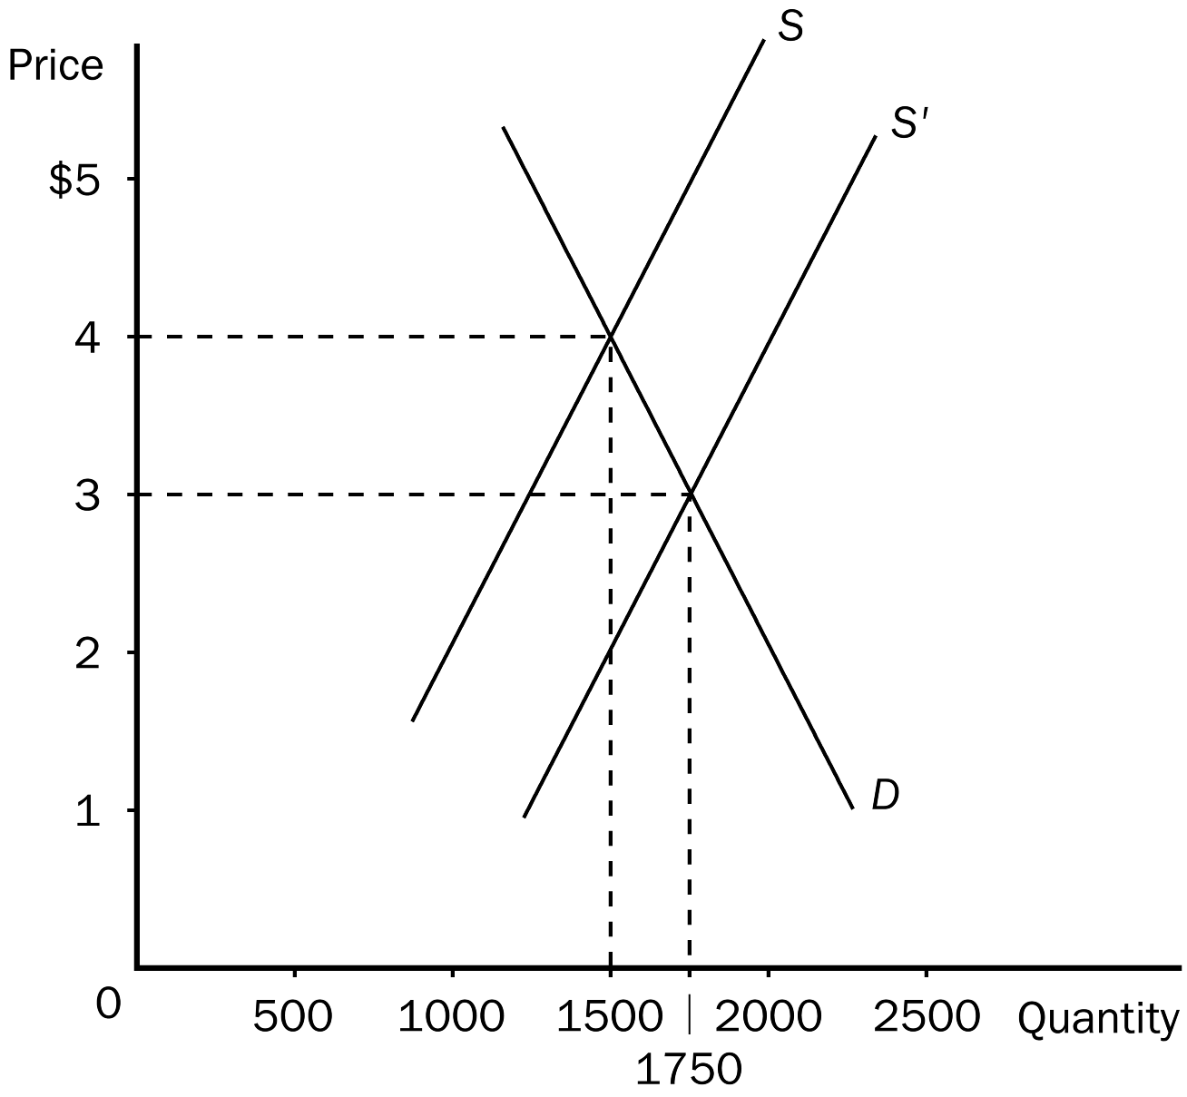
b. price elastic
c. price unit elastic
d. income elastic
ANSWER: a. price inelastic
TYPE: M SECTION: 3 DIFFICULTY: 2
188. According to the graph, when a new, more productive strawberry was developed which caused supply to increase, strawberry farmers were
a. helped, since although price fell, total revenue increased, due to an inelastic demand curve.
b. hurt, since both price and total revenue fell due to an elastic demand curve.
c. hurt, since both price and total revenue fell due to an inelastic demand curve.
d. helped, since although price fell, total revenue increased, due to an elastic demand curve.
ANSWER: c. hurt, since both price and total revenue fell due to an inelastic demand curve.
TYPE: M SECTION: 3 DIFFICULTY: 3
189. According to the graph, when a new, more productive strawberry was developed which caused supply to increase, strawberry farmers’ total revenue
a. fell from $6000 to $5250 since demand is elastic.
b. fell from $6000 to $5250 since demand is inelastic.
c. rose from $5250 to $6000 since demand is elastic.
d. fell from $6000 to $5250 since supply is elastic.
ANSWER: b. fell from $6000 to $5250 since demand is inelastic.
TYPE: M SECTION: 3 DIFFICULTY: 3
190. There are fewer farmers in the United States today than 200 years ago because of
a. more educational opportunities and increases in farm technology.
b. increased government regulations in farming and increased farm technology.
c. an elastic food demand and more attractive urban alternatives to farming.
d. increases in farm technology and an inelastic food demand.
ANSWER: d. increases in farm technology and an inelastic food demand.
TYPE: M SECTION: 3 DIFFICULTY: 2
191. Which of the following best describes the change in farm population from 1950 to 2000?
a. a drop from 10 million to fewer than 3 million people.
b. a drop from 20 million to fewer than 5 million people.
c. an increase from 10 million to almost 12 million people.
d. a drop from 30 million to just over 6 million people.
ANSWER: a. a drop from 10 million to fewer than 3 million people.
TYPE: M SECTION: 3 DIFFICULTY: 2
192. Between 1950 to 2000 there was a
a. 70 percent drop in the number of farmers, but farm output more than doubled.
b. 50 percent drop in the number of farmers, but farm output more than doubled.
c. 30 percent drop in the number of farmers, but farm output more than tripled.
d. 20 percent drop in the number of farmers, but farm output more than tripled.
ANSWER: a. a 70 percent drop in the number of farmers, but farm output more than doubled.
TYPE: M SECTION: 3 DIFFICULTY: 2
193. An increase in farm technology which increases market supply is
a. good for farmers because it raises prices for their products, but bad for consumers because it raises prices consumers pay for food.
b. bad for farmers because total revenue will fall, but good for consumers because prices for food will fall.
c. good for farmers because it raises prices for their products, and also good for consumers because more output is available for consumption.
d. bad for farmers because total revenue will fall, and bad for consumers because farmers will raise the price of food to increase their total revenue.
ANSWER: b. bad for farmers because total revenue will fall, but good for consumers because prices for food will fall.
TYPE: M SECTION: 3 DIFFICULTY: 2
194. Farm programs that pay farmers not to plant crops on all their land
a. hurt farmers by lowering their total revenue, and hurt consumers by causing shortages of some food items.
b. help farmers by cutting costs, which helps consumers by lowering food prices.
c. help farmers by increasing total revenue in the market, but hurt consumers by raising prices.
d. help farmers directly since they receive government payments, but has no real effect on consumers.
ANSWER: c. help farmers by increasing total revenue in the market, but hurt consumers by raising prices.
TYPE: M SECTION: 3 DIFFICULTY: 2
195. Suppose that you are in charge of pricing at a local sandwich shop. The business needs to increase revenue and your job is on the line. If the demand for sandwiches is elastic you
a. should increase the price of sandwiches.
b. should decrease the price of sandwiches.
c. should not change the price of sandwiches.
d. could not determine what to do with price until you determine whether supply is elastic or inelastic.
ANSWER: b. should decrease the price of sandwiches.
TYPE: M SECTION: 1 DIFFICULTY: 2

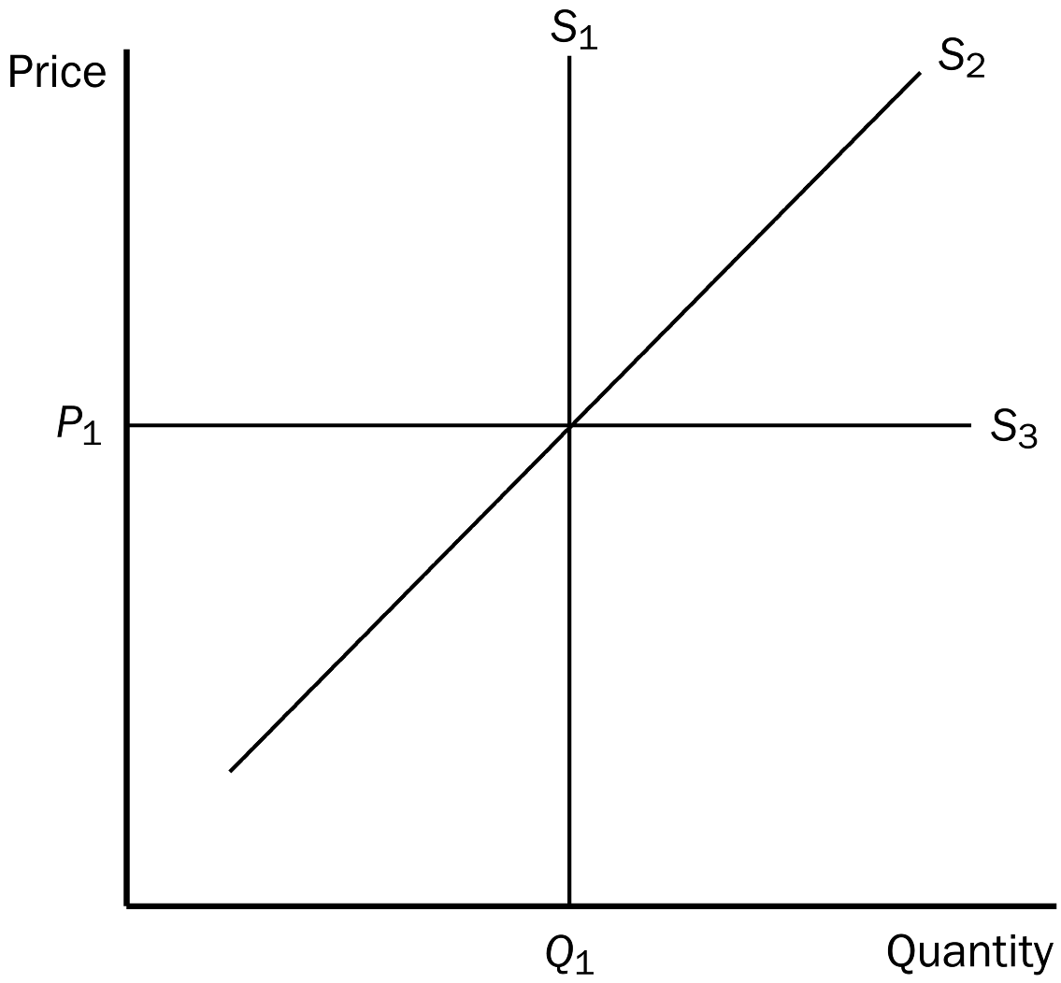
196. In the graph shown, which supply curve is perfectly inelastic?
a. S₁
b. S₂
c. S₃
d. It is impossible to tell without more information.
ANSWER: a. S₁
TYPE: M SECTION: 2 DIFFICULTY: 1
197. In the graph shown, which supply curve is most likely the long-run supply curve?
a. S₁
b. S₂
c. S₃
d. All of the above are equally likely to be the long-run supply curve.
ANSWER: c. S₃
TYPE: M SECTION: 2 DIFFICULTY: 2
198. Suppose a producer is able to separate customers into two groups, one having a price inelastic demand and the other having a price elastic demand. If the producer’s objective is to increase total revenue, she should
a. increase the price charged to customers with the price elastic demand and decrease the price charged to customers with the price inelastic demand.
b. decrease the price charged to customers with the price elastic demand and increase the price charged to customers with the price inelastic demand.
c. charge the same price to both groups of customers.
d. increase the price for both groups of customers.
ANSWER: b. decrease the price charged to customers with the price elastic demand and increase the price charged to customers with the price inelastic demand.
TYPE: M SECTION: 1 DIFFICULTY: 3
199. A bakery would be willing to supply 500 bagels per day at a price of $0.50 each. At a price of $0.80, the bakery would be willing to supply 1100. Using the midpoint method, the elasticity of supply for bagels would be
a. 0.61.
b. 0.77.
c. 1.24.
d. 1.63.
ANSWER: d. 1.63.
TYPE: M SECTION: 2 DIFFICULTY: 3
200. You have just been hired as a business consultant to determine what pricing policy would be appropriate in order to increase the total revenue of a major shoe store. The first step you would take is to
a. increase the price of every shoe in the store.
b. look for ways to cut costs and increase profit for the store.
c. determine the elasticity of demand for the store’s products.
d. suggest that the store purchase an entirely new line of shoes that they could sell more cheaply.
ANSWER: c. determine the elasticity of demand for the store’s products.
TYPE: M SECTION: 1 DIFFICULTY: 2
201. Harry’s Barber Shop increased its total monthly revenue from $1500 to $1800 when it raised the price of a haircut from $5 to $9. The price elasticity of demand for Harry’s Haircuts is
a. 0.318.
b. 0.700.
c. 1.125.
d. 0.416.
ANSWER: b. 0.700.
TYPE: M SECTION: 1 DIFFICULTY: 3
202. Barb’s Bakery made $200 last month selling 100 loaves of bread. This month it made $300 selling 60 loaves of bread. The price elasticity of demand for Barb’s bread is
a. 0.583.
b. 1.25.
c. 0.266.
d. 1.11.
ANSWER: a. 0.583.
TYPE: M SECTION: 1 DIFFICULTY: 3
203. You are in charge of the local city-owned golf course. You need to increase the revenue generated by the golf course in order to meet expenses. The mayor advises you to increase the price of a round of golf. The city manager recommends reducing the price of a round of golf. You realize that
a. the mayor thinks demand is elastic and the city manager thinks demand is inelastic.
b. both the mayor and the city manager think that demand is elastic.
c. both the mayor and the city manager think that demand is inelastic.
d. the mayor thinks demand is inelastic and the city manager thinks demand is elastic.
ANSWER: d. the mayor thinks demand is inelastic and the city manager thinks demand is elastic.
TYPE: M SECTION: 1 DIFFICULTY: 2
204. Muriel’s income elasticity of demand for football tickets is 1.50. All else equal, this means that if her income increase by 20 percent, she will buy
a. 150 percent more football tickets.
b. 50 percent more football tickets.
c. 30 percent more football tickets.
d. 20 percent more football tickets.
ANSWER: c. 30 percent more football tickets.
TYPE: M SECTION: 1 DIFFICULTY: 3
205. When her income increased from $10,000 to $20,000, Heather’s consumption of macaroni decreased from 10 pounds to 5 pounds and her consumption of soy-burgers increased from 2 pounds to 4 pounds. We can conclude that for Heather,
a. macaroni and soy-burgers are both normal goods with income elasticities equal to 1.
b. macaroni is an inferior good and soy-burgers are normal goods; both have income elasticities of 1.
c. macaroni is an inferior good with an income elasticity of –1 and soy-burgers are normal goods with an income elasticity of 1.
d. macaroni and soy-burgers are both inferior goods with income elasticities equal to -1.
ANSWER: c. macaroni is an inferior good with an income elasticity of –1 and soy-burgers are normal goods with an income elasticity of 1.
TYPE: M SECTION: 1 DIFFICULTY: 3
206. Last month, sellers of Good Y took in $100 and sold 50 units of Good Y. This month sellers of Good Y raised their price, took in $120 and sold 40 units of Good Y. At the same time, the price of Good X stayed the same, but sales of Good X increased from 20 units to 40 units. We can conclude that Goods X and Y are
a. substitutes, and have a cross-price elasticity of 0.60.
b. complements, and have a cross-price elasticity of 0.60.
c. substitutes, and have a cross-price elasticity of 1.67.
d. complements, and have a cross-price elasticity of 1.67.
ANSWER: c. substitutes, and have a cross-price elasticity of 1.67.
TYPE: M SECTION: 1 DIFFICULTY: 3
207. Suppose that the cross-price elasticity of demand between hot dogs and mustard is –2.00. This implies that a 20 percent increase in the price of hot dogs will cause the quantity of mustard purchased to
a. fall by 200 percent.
b. fall by 40 percent.
c. rise by 200 percent.
d. rise by 40 percent.
ANSWER: b. fall by 40 percent.
TYPE: M SECTION: 1 DIFFICULTY: 2
208. In January the price of widgets was $2.00 and Wendy’s Widgets produced 100 widgets. In February the price of widgets was $2.50 and Wendy’s Widgets produced 150 widgets. In March the price of widgets was $3.00 and Wendy’s Widgets produced 200 widgets. The price elasticity of supply of Wendy’s Widgets was
a. 1.80 when the price increased from $2.00 to $2.50 and 1.57 when the price increased from $2.50 to $3.00.
b. 2.00 when the price increased from $2.00 to $2.50 and 1.66 when the price increased from $2.50 to $3.00.
c. 1.66 when the price increased from $2.00 to $2.50 and 1.50 when the price increased from $2.50 to $3.00.
d. 0.56 when the price increased from $2.00 to $2.50 and 0.64 when the price increased from $2.50 to $3.00.
ANSWER: a. 1.80 when the price increased from $2.00 to $2.50 and 1.57 when the price increased from $2.50 to $3.00.
TYPE: M SECTION: 2 DIFFICULTY: 3
209. Suppose that when the price of corn is $2 per bushel, farmers can sell 10 million bushels. When the price of corn is $3 per bushel, farmers can sell 8 million bushels. Which of the following statements is true?
a. The demand for corn is income inelastic, and so an increase in the price of corn will increase the income of corn farmers.
b. The demand for corn is income elastic, and so an increase in the price of corn will increase the income of corn farmers.
c. The demand for corn is price inelastic, and so an increase in the price of corn will increase the income of corn farmers.
d. The demand for corn is price elastic, and so an increase in the price of corn will increase the income of corn farmers.
ANSWER: c. The demand for corn is price inelastic, and so an increase in the price of corn will increase the income of corn farmers.
TYPE: M SECTION: 3 DIFFICULTY: 3
210. If marijuana were legalized, it is likely that there would be a increase in the supply of marijuana. Advocates of marijuana legalization argue that this would significantly reduce the amount of revenue going to the criminal organizations that currently supply marijuana. These advocates believe that the
a. supply for marijuana is price elastic.
b. demand for marijuana is price elastic.
c. supply for marijuana is price inelastic.
d. demand for marijuana is price inelastic.
ANSWER: d. demand for marijuana is price inelastic.
TYPE: M SECTION: 3 DIFFICULTY: 3
TRUE/FALSE
1. Demand for a good is said to be inelastic if the quantity demanded increases substantially when the price falls by a small amount.
ANSWER: F TYPE: T SECTION: 1
2. Necessities tend to have price inelastic demands, whereas luxuries have price elastic demands.
ANSWER: T TYPE: T SECTION: 1
3. Goods with close substitutes tend to have more elastic demands than do goods without close substitutes.
ANSWER: T TYPE: T SECTION: 1
4. The demand for Rice Krispies is more elastic than the demand for cereal.
ANSWER: T TYPE: T SECTION: 1
5. The demand for gasoline will respond more to a change in price over a period of five weeks than over a period of five years.
ANSWER: F TYPE: T SECTION: 1
6. The price elasticity of demand is defined as the percentage change in quantity demanded divided by the percentage change in price.
ANSWER: T TYPE: T SECTION: 1
7. The price of calculators increases by 15 percent and the quantity demanded per week falls by 45 percent. The price elasticity of demand is 3.
ANSWER: T TYPE: T SECTION: 1
8. Demand is inelastic if the elasticity is greater than 1.
ANSWER: F TYPE: T SECTION: 1
9. If the price elasticity of demand is equal to 0, demand is unit elastic.
ANSWER: F TYPE: T SECTION: 1
10. The midpoint method is used to calculate elasticity between two points because it gives the same answer regardless of the direction of the change .
ANSWER: T TYPE: T SECTION: 1
11. The flatter the demand curve that passes through a given point, the more inelastic the demand.
ANSWER: F TYPE: T SECTION: 1
12. If demand is perfectly inelastic, the demand curve is vertical, and elasticity is equal to 0.
ANSWER: T TYPE: T SECTION: 1
13. When demand is inelastic, a decrease in price increases total revenue.
ANSWER: F TYPE: T SECTION: 1
14. A linear demand curve has constant elasticity, but not constant slope.
ANSWER: F TYPE: T SECTION: 1
15. A linear demand curve becomes more elastic as price falls.
ANSWER: F TYPE: T SECTION: 1
16. The income elasticity of demand is defined as the percentage change in quantity demanded divided by the percentage change in income.
ANSWER: T TYPE: T SECTION: 1
17. Normal goods have negative income elasticities of demand, while inferior goods have positive income elasticities of demand.
ANSWER: F TYPE: T SECTION: 1
18. Cross-price elasticity of demand measures how the quantity demanded of one good changes as the price of another good changes.
ANSWER: T TYPE: T SECTION: 1
19. Cross-price elasticity is used to determine whether goods are inferior or normal goods.
ANSWER: F TYPE: T SECTION: 1
20. Price elasticity of supply measures how much the quantity supplied responds to changes in the price.
ANSWER: T TYPE: T SECTION: 2
21. Supply is said to be inelastic if the quantity supplied responds substantially to changes in the price, and elastic if the quantity supplied responds only slightly to price.
ANSWER: F TYPE: T SECTION: 2
22. Supply tends to be more elastic in the short run and more inelastic in the long run.
ANSWER: F TYPE: T SECTION: 2
23. When the price of knee braces increased by 25 percent, the Brace Yourself Company increased their quantity supplied of knee braces per week by 75 percent. BYC’s price elasticity of supply of knee braces is 0.33.
ANSWER: F TYPE: T SECTION: 2
24. If a supply curve is horizontal it is said to be perfectly elastic and the price elasticity of supply approaches infinity.
ANSWER: T TYPE: T SECTION: 2
25. A government program that reduces land under cultivation hurts farmers but helps consumers.
ANSWER: F TYPE: T SECTION: 3
26. OPEC failed to maintain a high price of oil in the long run because both the supply of oil and the demand for oil are more elastic in the long run than in the short run.
ANSWER: T TYPE: T SECTION: 3
27. Drug interdiction, which reduces the supply of drugs, may decrease drug-related crime because the demand for drugs is inelastic.
ANSWER: F TYPE: T SECTION: 3
SHORT ANSWER
1. Consider the following pairs of goods. Which would you expect to have the more elastic demand? Why?
a. water or diamonds
b. insulin or nasal decongestant spray
c. food in general or breakfast cereal
d. gasoline over the course of a week or gasoline over the course of a year
e. personal computers or IBM personal computers
ANSWER: a. Diamonds are luxuries, and water is a necessity. Therefore, diamonds have the more elastic demand.
b. Insulin has no close substitutes, but decongestant spray does. Therefore, nasal decongestant spray has the more elastic demand.
c. Breakfast cereal has more substitutes than does food in general. Therefore, breakfast cereal has the more elastic demand.
d. The longer the time period, the more elastic demand is. Therefore, gasoline over the course of a year has the more elastic demand.
e. There are more substitutes for IBM personal computers than there are for personal computers. Therefore, IBM personal computers have the more elastic demand.
TYPE: S SECTION: 1
2. You own a small town movie theatre. You currently charge $5 per ticket for everyone who comes to your movies. Your friend who took an economics course in college tells you that there may be a way to increase your total revenue. Given the demand curves shown, answer the following questions.

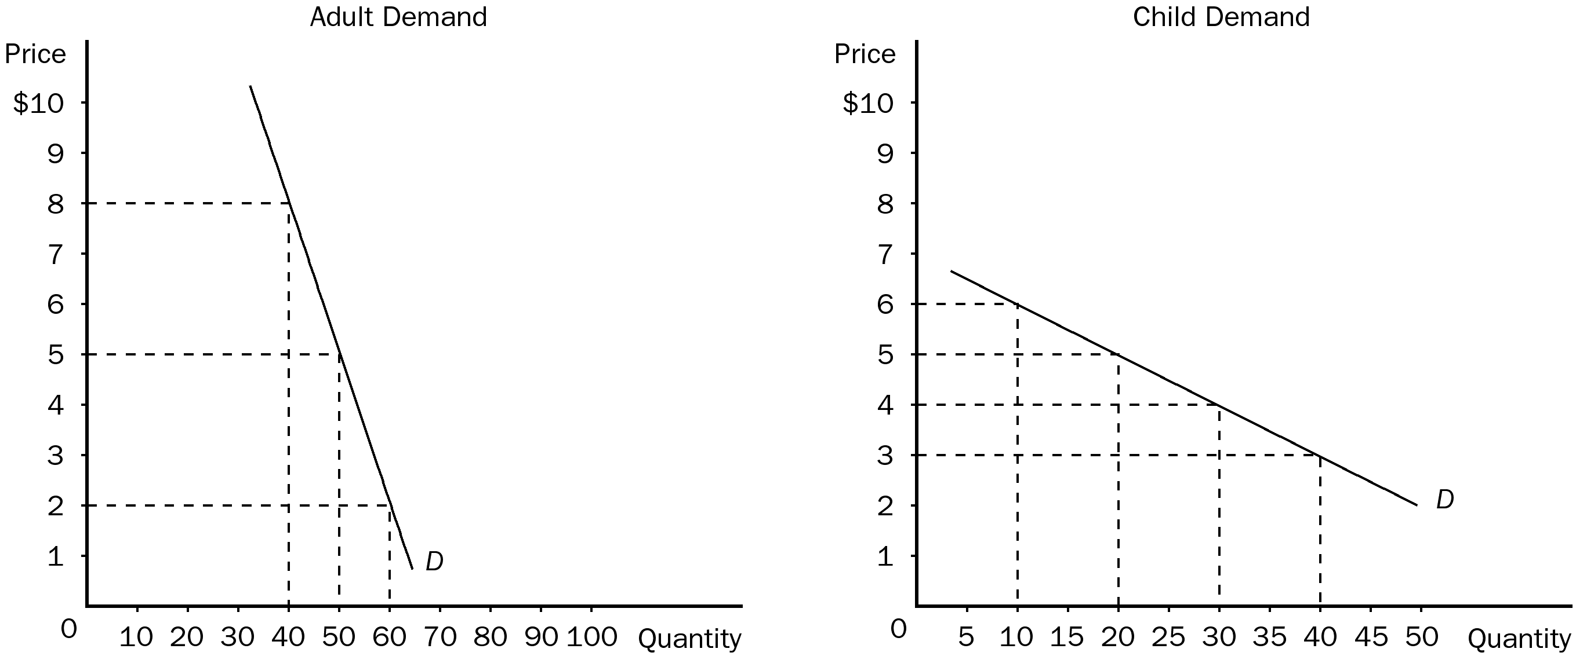

a. What is your current total revenue for both groups?
b. The elasticity of demand is more elastic in which market?
c. Which market has the more inelastic demand?
d. What is the elasticity of demand between the prices of $5 and $2 in the adult market? Is this elastic or inelastic?
e. What is the elasticity of demand between $5 and $3 in the children’s market? Is this elastic or inelastic?
f. Given the graphs and what your friend knows about economics, he recommends you increase the price of adult tickets to $8 each and lower the price of a child’s ticket to $3. How much could you increase total revenue if you take his advice?
ANSWER:
a. Total revenue from children’s tickets is $100 and from adult tickets is $250. Total revenue from all sales would be $350.
b. the demand for children’s tickets is more elastic.
c. The adult ticket market has the more elastic demand.
d. The elasticity of demand between $5 and $2 is 0.26 or inelastic.
e. The elasticity of demand between $5 and $3 is 1.33 or elastic.
f. If price is increased to $8 for adult tickets (maximum for the graph) and price decreased to $3 for child tickets (minimum for graph), total revenue would increase to $440 ($8 × 40 + $3 × 40) or $90 more than before.
TYPE: S SECTION: 1
3. Use the graph shown to answer the following questions. Put the correct letter in the blank.

a. The elastic section of the graph is represented by section _______.
b. The inelastic section of the graph is represented by section _______.
c. The unit elastic section of the graph is represented by section _______.
d. The portion of the graph in which a decrease in price would cause total revenue to fall would be _________.
e. The portion of the graph in which a decrease in price would cause total revenue to rise would be _________.
f. The portion of the graph in which a decrease in price would not cause a change in total revenue would be _________.
g. The section of the graph in which total revenue would be at a maximum would be _______.
h. The section of the graph in which elasticity is greater than 1 is _______.
i. The section of the graph in which elasticity is equal to 1 is ______.
j. The section of the graph in which elasticity is less than 1 is _______.
ANSWER:
a. A
b. C
c. B
d. C
e. A
f. B
g. B
h. A
i. B
j. C
TYPE: S SECTION: 1
4. Using the midpoint method, compute the elasticity of demand between points A and B. Is this portion of the curve elastic or inelastic? Interpret your answer with regard to price and quantity demanded. Now compute the elasticity of demand between points B and C. Is this portion of the curve elastic or inelastic?

ANSWER: In the section of the demand curve from A to B, the elasticity of demand would be 2.5. This would be an elastic portion of the curve. This would mean that for every 1 percent change in price, quantity demanded would change by 2.5 percent.
In the section of the demand curve from B to C, the elasticity of demand would be .75. This would be an inelastic portion of the curve. This would mean that for every 1 percent change in price, quantity demanded would change by 0.75 percent.
TYPE: S SECTION: 1
5. When the Shaffers have a monthly income of $4,000, they would usually eat out 8 times a month. Now that the couple makes $4,500 a month, they eat out 10 times a month. Compute the couple’s income elasticity of demand using the midpoint method. Explain your answer. (Is a restaurant meal a normal or inferior good to the couple?)
ANSWER: The income elasticity of demand for the Shaffers is 1.89. Since the income elasticity of demand is positive, this would be interpreted as a normal good.
TYPE: S SECTION: 1
6. Recently, in Smalltown, the price of Twinkies fell from $0.80 to $0.70. As a result, the quantity demanded of Ho-Ho’s decreased from 120 to 100. What would be the appropriate elasticity to compute? Using the midpoint method, compute this elasticity. What does your answer tell you?
ANSWER: The appropriate elasticity to compute would be cross-price elasticity. The cross-price elasticity for this example would be 1.36. The two goods are substitutes because the cross-price elasticity is positive.
TYPE: S SECTION: 1

